Nutrition for pregnant(1-6)

1-Pregnancy
Patient education:
-For women need pregnancy:
Stop OCC Three months to give time to restore balanced hormone ( homeostasis) and to allow accurate dating of pregnancy.

Basic concept:
-Pregnancy is a very normal event in the life cycle and usually goes very smoothly, especially if you have regular medical care. Antenatal care is considered to be the best opportunity in life for preventive medicine.
-Your baby is very special and deserves every opportunity to get a healthy life.

-Areas that need to be checked include:
- blood count
- blood grouping and Rhesus antibodies (Rh factor)
- immunity against infections that may affect the baby (e.g. hepatitis B and C, HIV)
- blood pressure
- urine (for evidence of diabetes or pre-eclampsia)
- progress of the baby (e.g. size of uterus, heartbeat)
- mother's progress, including emotional state
- blood sugar (for possible diabetes)
-The recommended routine visit is as early as possible and then every 4 to 6 weeks until 28 weeks of gestation, then every 2 weeks until 36 weeks, and then weekly until the baby arrives (usually 40 weeks).

-Avoid smoking or being in a negative smoking area. smoking—retards growth and should be stopped (if impossible, limit to 3-6 smokes per day).

-avoid using any OTC medication without contacting your physician or pharmacist. Avoid using drugs that are teratogen (see teratogen category of the drug)
-What is usually prescribed?
Folic acid is now recommended for 4 weeks before getting pregnant, then for the first 3 months.
No tablets are needed if you have a healthy diet and do not have severe morning sickness. Also, iron may be prescribed for anemia risk and calcium may be prescribed for fetus bone requirement.

-Nutrition for pregnant:
A healthy diet is very important:
- Eat most:
  - fruit and vegetables (at least 4 serves)
  - cereals and bread (4-6 serves)
- Eat moderately:
  - dairy products—3 cups (600 mL) of milk or equivalent in yoghurt or cheese
  - lean meat, poultry or fish—1 or 2 serves (at least 2 serves of red meat per week)
- Eat least:
  - sugar and refined carbohydrates (e.g. sweets, cakes, biscuits, soft drinks)
  - polyunsaturated margarine, butter, oil and cream

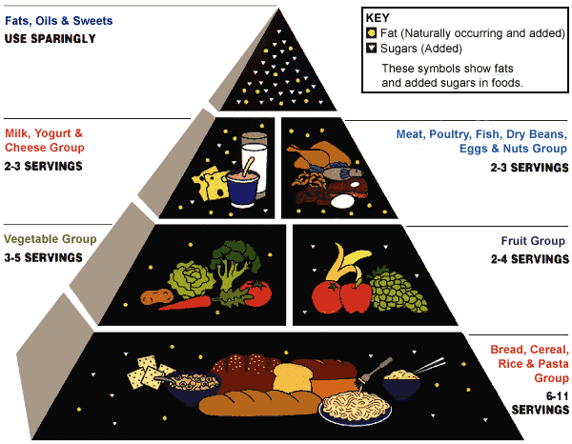
some common problems from pregnancy are ( 7-12 )

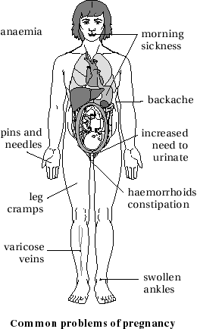

Miscarriage (13-18 )
A miscarriage, which is called a spontaneous abortion in medical terms, is the spontaneous ending of pregnancy before the baby (fetus) can survive outside.
Patient education:
Concepts:
-The main thing is to remember that it was nothing that you did wrong, and so you should not feel any sense of blame or guilt.
-About 1 in 4 pregnancies are 'lost'. Most are lost in the first 14 weeks and are obvious to the mother.
-The first main symptom is loss of blood from the vagina, which can vary from slight to a heavy flow.
- if the woman feels emotionally upset or depressed with feelings of loss and grief. If so, sherequire help of psychologist.

Physician contact:
physician contact is recommended to determine the cause of miscarriage, start drug treatment for symtpoms “fever, heavy bleeding, severe pain or an offensive discharge” or if a surgical cleaning of your uterus is required, especially if the miscarriage was early in the pregnancy and bleeding continues. This is called a dilation and curettage (D&C).
General advice:
-reduced activity and rest for at least 48 hours and at least a week off work.
-You are no more likely to have a repeat miscarriage than any other pregnant woman.
-There is no special treatment to prevent any further miscarriages, and it is best left to natural means. However, it is advisable to keep healthy life.
-Your next period may be heavy and abnormal.
-You can safely start trying to get pregnant again very soon. It is best to wait until you have had at least one normal period.
-partners have to be very patient and understanding to the psychological state of his wife.

General principles of prescribing in lactation(19-24)

➣ Consider whether drug therapy is necessary, or if it can be delayed until weaning
➣ Avoid drugs known to cause serious toxicity in adults or children
➣ Avoid new drugs, for which little data are available, where there is an older, more established alternative
➣Within a drug class, choose one that passes poorly into milk (based on the physicochemical propertiesof the drug and published data) and has no active metabolites. If possible, avoid drugs that have long pediatric half-lives, as these may accumulate in the infant
➣Monotherapy is preferable to multiple drug regimens, which may have additive adverse effects
➣ Choose a route of administration which minimizes maternal drug levels, e.g. topical/local rather than systemic
➣ If possible make dosing after breastfeeding. This strategy may not work in the case of a newborn infant who nurses more frequently
➣ Long-acting formulations of drugs likely to cause serious side-effects are best avoided as it is difficultto time feeds to avoid significant amounts of drug in breast milk
➣ Monitor the infant for adverse effects. In some cases it may also be necessary to monitor infant’s plasmalevel of a drug

Postnatal blues(25-30)

'The blues' are a very common problem that arises in the first 2 weeks (usually from day 3 to day 5) after childbirth.It is quite common for women to feel emotional and flat after childbirth;

Patient education:
-This condition is apparently due to hormonal changes and the stress after the long-awaited event.
-What are the symptoms?
Feeling depressed, mood swings, irritability, feeling emotional (e.g. crying easily),lacking confidence (e.g. in bathing and feeding the baby), tiredness.

What is the outcome?
Fortunately 'the blues' are a passing phase and last only a few days. It is important to get plenty of help and rest until they go away and you feel normal.
What should you do?
-All you really need is encouragement and support from your partner, family and friends, so tell them how you feel.Talk over your problems with a good listener (perhaps another mother with a baby).
-If the blues last longer than 14 days, postnatal depression is suspected which require physician contact.
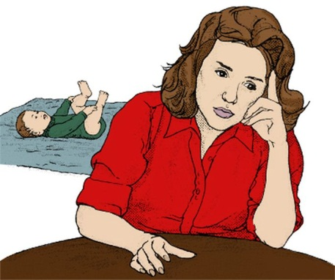

Autism(31-36 )
Autism is a develop mental disorder commencing in the first 3 years of life. It affects at least 8 children in 10 000; boys are 4 times more likely than girls to be affected.

Patient education:
- inability of the child to form normal social relationships, even with his or her own parents
- delayed and disordered language development (about one-half of all autistic children never learn to speak effectively)
- obsessive behaviours such as hand flapping, spinning and hoarding unusual objects
- restricted range of interests, and lack of imagination
What is the cause?
The cause of autism is unknown but may be the problem appears to lie in that part of the brain responsible for the development of language.
What is the treatment?
-There is no medical treatment for autism but early intervention program is requiredeither in a specialised facility or in a regular school with specialist backup.
-Speech therapy can help with language development.
-If there is a deterioration in behaviour or skills, a thorough medical check is required because the autistic child does not indicate pain or communicate clearly.
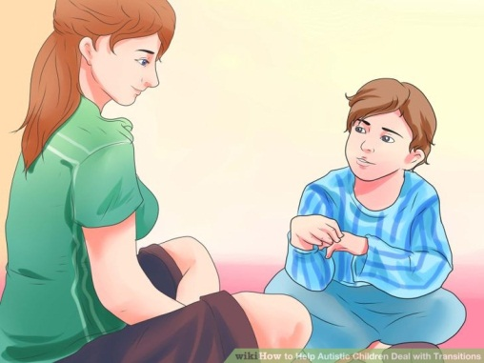
Bed-wetting (enuresis)( 37-42 )
What is nocturnal enuresis (bed-wetting)?
It refers to bed-wetting at night in children (or adults) at a time when control of urine could be reasonably expected.
Patient education:
Concept:-Bed-wetting at night is common in children up to the age of 5. About 50% of 3-year-olds wet their beds, as do 20% of 4-year-olds and 10% of 5-year-olds.
-It is considered a problem if regular bed-wetting occurs in children 6 years and older or ongoing wetting during the daytime
-It is not the child's fault
-It rarely has an emotional cause
-It gets better naturally
-It requires a gentle, non-interfering approach

The cause:
-the cause is unknown but may be a delay in development of bladder control. Others may have a small bladder capacity or a sensitive bladder.
It seems to run in families.
Most bed-wetting episodes occur in a deep sleep.
secondary enuresis can be psychological; it commonly occurs during a period of stress or anxiety, such as separation from a parent or the arrival of a new baby.
How should parents treat the child?
If no cause is found, reassure the child that there is nothing wrong, and that it is a common problem that will eventually go away. There are some important ways of helping the child adjust to the problem:
- Do not punish the child.
- Visit toilet just before going to bed.
- Praise the child often, when appropriate.
- Avoid drinking water 2 – 3 hrs before bed times but not avoid drinking during the day.
- Do not stop the child drinking after the evening meal.
- Do not wake the child at night to visit the toilet.
- Use a night light to help the child who wakes.
- Make sure the child has bath before going to kindergarten or school.
- Avoid drinking caffeine due to its diuretic action which increases urination.

What are the treatment options?
if the problem continue after 6 year, the bed-wetting alarm system is generally regarded to be the most effective. The bed alarm makes a loud noise when urine is passed. The child wakes, switches off the alarm and visits the toilet. This method works well, especially in older children.

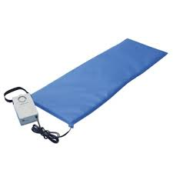
Drugs like desmopressin (Minirin®)or oxybutynin (Uripan®)can be used and may be very effective in some children; it is sprayed into each nostril at night, and seems to be very effective if the alarm system is ineffective.
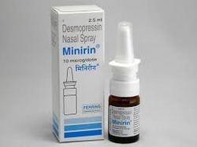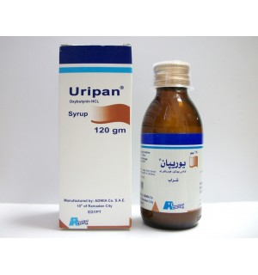

Bow legs and knock knees(43-48)
Knock knees and bow legs are relatively common in infants and children but are usually no cause for concern. They are stages that children pass through and it is important to remember that most legs are perfectly straight by the teenage years.
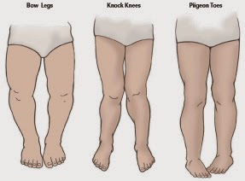
Patient education:
-most legs are perfectly straight by the teenage years.
-Bow legs are very common up to the age of 3 years. In fact, they are quite normal up to the age of 2 or 3.
-Bow legs usually correct themselves when the child starts walking, so much so that from about the age of 4 there is a tendency for the child to develop knock knees.
How can you check progress?
-monitored by measuring the distance between the knees (DBK). If this is greater than 6 cm and not improving at 4 years and older, it is advisable to have them checked by your doctor.
Knock knees
Patient education:
-Knock knees are also normal in children and most have these between the ages of 3 years and 8 years.
How can you check progress?
Measure the distance between the ankles (DBA). It should be checked by your doctor if the DBA is greater than 8 cm after the age of 8 years and not improving.

crying baby (49-54 )

Patient education:
Concepts:
-Crying is an important expression to develop a proper interaction between the baby and parent or carer.
-During the first few weeks, the average baby sleeps a lot and when awake cries loud and often, usually without tears. From 6 weeks onwards, the baby has some wakeful periods without crying. By 6 months spends most hours a day playing without crying.
-Crying is excessive and become a problem when it lasts for long periods when the baby should be sleeping or playing.
A check list of common causes
- hunger
- wet or soiled nappy (discomfort to babies)
- Teething:Babies usually cut their first teeth between the ages of 6 months and 2 years. The gum is often swollen and sore at the spots where the tooth erupts. This discomfort can make the baby cry, but it does not usually last for longer than a week. Teething may be with fever.
- infant colic
- loneliness or seeking attention (If the baby stops crying when picked up, the cause may well be this lonely feeling).
- infection( indicated by a fever, running nose and the baby pulling at his or her ear).
What should be done?
Simply check out and attend to these common causes.
crying episodes are not the mother's (or carer's) fault.
You must report any unusual symptoms and contact physician if needed.

Infant colic( 55-60 )

This is one of the commonest causes of unexplained crying in an infant. Some babies develop from as early as 1-2 weeks of age and lasts until 12-16 weeks.

Patient education:
Concepts:
- It typically develops in the late afternoon and early evening and lasts for about 3hours in a day.
- may be indicated by Gas in GIT (make noise) & G.I. disturbance or not.
- avoid Cow’s milk allergy, Allergy to milk proteins
-Eructating the baby at the middle and at the end of feeding will alleviate the case
-Colic is diagnosis of exclusion, meaning crying of unknown causes.
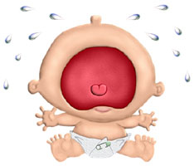

Teething(61-66 )
Baby teeth (milk or deciduous teeth)
- Babies usually cut their teeth from age 6 months until 2-3 years.
- Usually the first set (20 teeth) is complete soon after the second birthday.
- These teeth are lost between 6 and 12 years.
Patient education:
What are the symptoms of teething?
- The gum is slightly swollen and red. This may cause little or no discomfort, or may be quite painful.
- The baby is more clinging and fretful than normal.
- The baby dribbles more than usual.
- The baby wants to chew on something (such as fingers).
- The baby has difficulty with sleeping.
- The problem usually settles quickly.
Managing Teething
- Gentle massaging of the gum with the forefinger wrapped in a soft cloth or gauze pad is comforting.
- Allow the baby to chew on a clean, cold, lightly moistened face washer. (A piece of apple can be placed inside the face washer.)
- Give the baby a teething ring (kept cold in the refrigerator).
Medicine is usually not necessary for teething. Paracetamol mixture should be used for any discomfort.

Physiological jaundice(67-72 )

It is a transient hyperbilirubinemia( increased in unconjugated bilirubin) but is quit below toxic level.Appear as yellowish coloration of skin.

Patient education:
Concepts:
- Some new born exhibit hepatic insufficiency that resolve within first 4-6 weeks
- condition subside continuously without therapy in 5-10 days
-recommend breast feeding, and some vitamin drops for baby.
- recommend phototherapy (blue light):
-The baby's skin and blood absorb these light waves. light to decrease serum bilirubin levels by converting bilirubin molecules in the body into water soluble isomers that can be excreted by the body. Blue light is most effective specially between 460-490nm.
-if prolonged hyperbilirubinamia, this can lead to kernictuous with signs of poor feeding, seizures, movement disorders which require immediate physician contact.
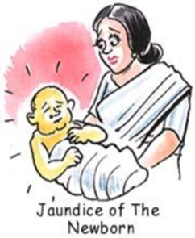

Encopresis (73-78)

Encopresis is the condition in a child over 4 years of age who regularly starts soiling his or her underclothes, after having previously been well toilet trained.

Patient education:
Concepts:
-Children do not usually have complete bowel control until at least 2½ years of age.
-About 1-2 children in 100 have the problem.
-Diarrhoea has to be excluded(The stools may be fully formed or partly formed).
-Bowel movements occur spontaneously into the underwear(no control or warning).
-The soiling has to be present for at least 1 month.
-This may follow a period of resistance to using toilets at kindergarten or school, on camping trips or outdoors.
What are the causes?
The commonest feature is constipation with false diarrhoea around the clogged up bowel. Sometimes the cause is not apparent.
Some apparent causes are:
- a poor diet, leading to constipation
- painful bowel movements (e.g. an anal fissure)
- stress or an emotional upset (e.g. parental separation)
- negative reaction to parents' obsession about toilet use

What is the management?
Role of parents
- A concerned, understanding and supportive approach is essential.
- Be sensitive to other stresses in your child's life.
- Do not shame or punish the child for 'dirty habits'.
- Provide a special high-fibre diet.
- Approach toilet training sensibly—for example, regular sitting on the toilet for 5 minutes 3 times a day (after each meal).
- laxative medication required to restore the bowel to its normal state
- Do not return to napkins.
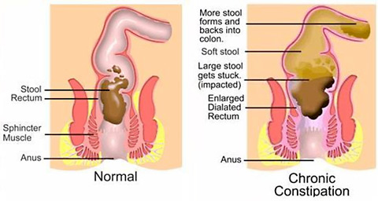

Febrile convulsions (79-84 )

Febrile convulsions are seizures that occur in young children when they have a high fever. They only occur when the child has a high temperature. The growing brains of little children are more sensitive to fever than are more mature brains, and when the normal brain activity is upset a seizure can occur. The fever is caused by an infection.

Patient education:
Concepts:
- Febrile convulsions may occur again.
- They usually occur from 6 months to 3 years of age.
- They cause no long-term problems,death, brain damage or epilepsy.
- They stop by 6 years of age. Who gets them?
- They are common and can affect any normal child. About 5 in every 100 children will have a seizure from a fever.
- They tend to run in families.
What are the risks?
Febrile convulsions (whether one or several) in normal children do not usually cause brain damage or epilepsy.
How do you manage a convulsion?
- Place the child on his or her side, chest down, with the head turned to one side. Never lie a fitting or unconscious child on his or her back. Do not force anything into the child's mouth.
- it is important to manage any fever as soon as it is noticed.keep the child cool, give fluids and paracetamol mixture.
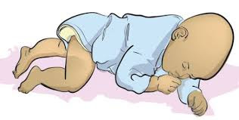
Immunisation of children (85-90)

The importance of immunisation
The use of vaccines during childhood has dramatically reduced the number of deaths from the basic infectious diseases. Immunisation is vital preventive medicine, and parents have a responsibility to make sure their children are immunised.

What diseases do we vaccinate against?
Disease | Nature
Diphtheria | Diphtheria is a bacterial infection that causes a membrane to grow across the throat and block the airway.
Whooping cough | Whooping cough (pertussis) is a serious bacterial infection of the chest that causes a dramatic cough in children as they struggle to breathe. It is still a common infection in our community, but immunisation has made it a milder disease.
Haemophilus influenza type | This is a serious bacterial infection that caused many deaths from meningitis and epiglottitis. B (HiB)
Tetanus | This is another bacterial infection; it causes a severe infection known as lockjaw. Tetanus can be easily picked up in the non-immune person through a simple injury such as a small cut or a nail breaking the skin.
Polio | severe viral infection of the nervous system. It causes paralysis of parts of the body. At first the vaccine was given by injection, but now is in the form of small liquid drops given on a spoon.
Measles | Measles is a very serious viral illness that has not been well controlled. It can cause serious brain damage (due to encephalitis) in its victims. The vaccine is now combined with mumps and rubella.
Mumps | Mumps is one of the well-known infectious diseases of childhood that is now being controlled with immunisation. It can infect the brain (meningitis and encephalitis) and the testicles in young men.
Hepatitis B | Hepatitis B vaccine should commence just after birth with boosters, usually combined with other vaccines.
Rubella | Rubella or German measles is not a serious disease except if contracted during the first 3 months of pregnancy. Being immune to rubella takes a great load off the mind of any expectant mother.
Are there any side effects?
The vaccines usually are free of side effects, although a mild reaction can occur. Sometimes an injection can cause the child to be quite ill with fever and it usually is the whooping cough (pertussis) component.
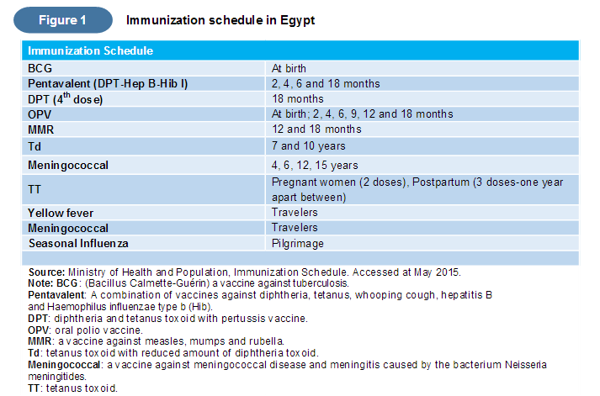

Dysmenorrhoea (painful periods)(91-96 )
Patient education:
What causes primary dysmenorrhoea?
It is caused by high levels of prostaglandins, which are natural substances produced by the lining of the uterus. One of the actions of prostaglandins is to cause the muscles of the uterus to contract tightly, thus producing cramping sensations.
What are the symptoms?
a dull dragging pain in the abdomen or lower back or in both areas; others have more severe cramping abdominal pain.
The pain is worse at the beginning of the period and may even start up to 12 hours before the menses appearand continue for 2 or 3 days. Some women may get nausea and vomiting.
What is the treatment?
-analgesic such as paracetamolor diclofenac.
- It often disappears after you have a baby or as you get older.
-Keeping fit by leading a healthy lifestyle (including avoiding smoking and undertaking regular exercise.
-If you get severe pain, rest in bed.
-Simple measures such as placing a hot-water bottle over the painful area and curling your knees up to your chest as you lie on your side may provide relief.
-Dysmenorrhoea is very common, but most cases are mild and do not require medical attention.
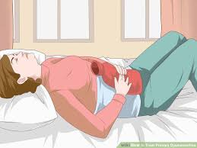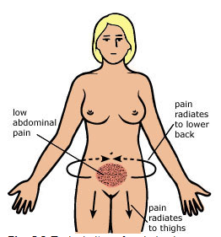
Endometriosis (97-102 )

The tissue lining your uterus is called the endometrium. Endometriosis is a condition in which fragments of the endometrium grow in other places such as the wall of the uterus, the ovaries, the ligaments inside the pelvis, the Fallopian tubes and on other pelvic organs.
Each cycle, the blood from these fragments cannot escape because it is embedded in tissue in the pelvis. Small blood blisters develop and irritate the tissues.
Patient education:
Concepts:
-till now we do not fully understand its mechanism.
-Many women with endometriosis have no symptoms at all, only diagnosed bylaproscope for infertility tests.
-1 in 100 will be affected by it.
-About 20% of women investigated for infertility have endometriosis (common cause).It can cause painful cysts inside the pelvis over uterus or ovary.
-Most often between the ages of 25 and 35.
-It is more common in women who have not had children.
-It is more common in some families.
What are the symptoms?
- painful or heavy periods
- a dragging pain in the back or pelvis or abdomen during periods
- pain during intercourse

How is it diagnosed?
It is indicated by the symptoms, but the only accurate method of diagnosis is a laparoscope passed through a small cut into the abdomen. The spots of endometriosis are seen as small red or black pockets.
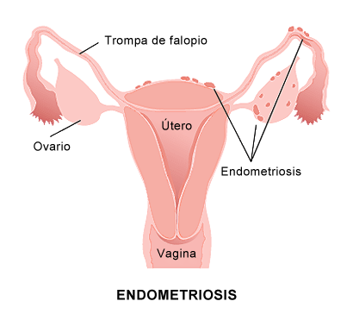
-What are the risks?
Endometriosis is a common cause of infertility. It can cause painful cysts inside the pelvis, and can affect the ovaries or the uterus. An operation may be necessary to remove the cysts, repair the ovaries or remove the uterus, but these measures are not usually necessary.
-What is the treatment?
Many women do not require treatment if mild symptoms. If necessary, however, endometriosis can be treated with drugs or surgery for infertility purposes.
-Surgical treatment
The ovaries and uterus are usually left intact but the endometrial tissue is destroyed by heat or laser and scar tissue is removed. The aim is to reduce symptoms and improve fertility.
-Medical treatment
Hormone treatment with one of the contraceptive pills, progestogens, aims to suppress the menstrual cycle, causing the endometrial cells to shrink and, hopefully, disappear. Hormones are usually taken for 6 to 12 months.

Hirsutism (103-108 )

the presence of excessive body or facial hair. For women, the areas most affected are the 'beard' area (upper lip, chin, front of the ears), the chest, the abdomen and the front of the thighs.
Patient education:
Concepts:
- if this occurs in the normal female hair-growth areas (such as the armpits, forearms, pubic area and around the nipples) there is no cause for concern.No therapy is needed if it is in normal areas
-only concerns if it is obvious to others
-A tendency to be 'hairy' may run in families or be prevalent in some races, such as those from the Mediterranean region.
-Certain medications, such as anti-epilepsy drugs and some oral contraceptive pills, can cause it.So full medical history is important.
What causes hirsutism?
It is due to excessive hair growth caused by overactive male sex hormones (present in all women).
What is the treatment?
- Cosmetic measures (such as bleaching, waxing and shaving) and treatment with depilatory creams or electrolysis (which is the only permanent cosmetic method of hair removal) can help. There is no evidence that shaving increases the rate of hair growth, but plucking the hair does stimulate growth. Do not pluck hairs around the lips and chin.
- Medical treatment with drugs such as spironolactone (only by physician) can be used if your hair growth is excessive and causes understandable social embarrassment. It will probably take at least 3 months for you to notice any difference in your hairiness, and for most women the hair grows back once they stop taking the medications.

Menopause (109-114 )

The menopause is the end of menstruation, which in most women occurs between the ages of 45 and 55 years. However, the term is used in a broader sense to describe the months or years before and after the last period, during which the periods become irregular and the body adjusts to reduced levels of female hormones. This may last 2-5 years or sometimes longer.
Patient education:
Concepts:
- the menopause is a natural fact of life and nothing to be embarrassed or worried about.
-Periods may stop abruptly or after a prolonged irregular pattern.
- Hot flushes may continue for months to after the periods cease.
-If you are slightly built or have a family history of osteoporosis, contact physician for this potential problem.
-Report to your doctor if you have a return of unusual bleeding.
-Contraception is advisable for 12 months after the last period.
-Continuing medical checks for breast examination, Pap smears and general health assessment are important if hormonal therapy is to be given.

What causes the menopause?
The female hormones, oestrogen and progestogen, are no longer produced by the ovary because of a decline and finally a complete absence of maturing eggs (ova).

Symptoms
Hot flushes and night sweating
-a sensation of heat, usually in the face and neck, but can be experienced from head to toe and last from seconds to minutes.
-They may be accompanied by night sweating, palpitations, headache, faintness and disturbed sleep,
-aggravated by hot foods and drinks, and stress.
-In themselves they are harmless, but they can cause tiredness and anxiety.
Vagina and bladder symptoms
The normally moist tissue of the vagina can become dry and inelastic. This can result in uncomfortable intercourse. This can be overcome by lubricating creams.
Emotional problems
A woman may experience fluctuating levels of energy and concentration with tiredness, irritability, lack of confidence and loss of interest in sexual activity. Occasionally anxiety and depression can be a problem.
Osteoporosis (thinning of bone).
It has been shown that reduced levels of oestrogen cause increased loss of calcium from bone tissue, which causes osteoporosis of varying degrees.
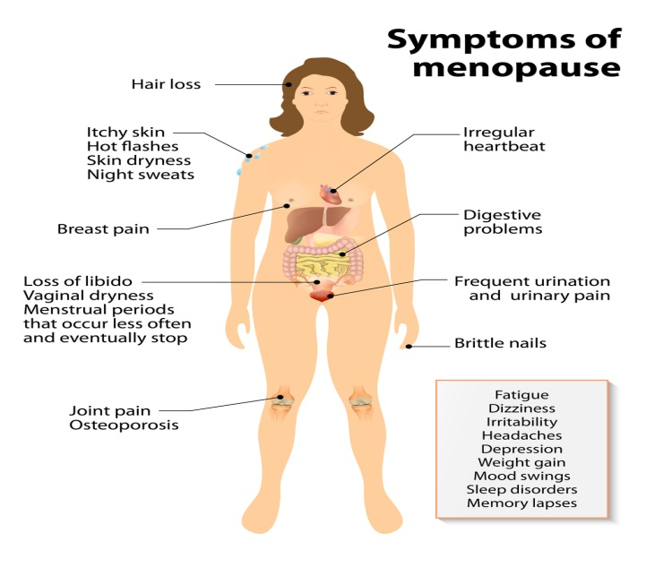
What should be done?
-While it is important to accept that the menopause is a natural fact of life.
-It is important to lead a healthy life: follow a correct diet, avoid obesity, get adequate relaxation and exercise, and reduce the use of cigarettes, caffeine and alcohol.
-It is normal and healthy to continue sexual relations, but a vaginal lubricant such as KY jelly may be necessary if your vagina is too dry.
- Hormones (both oestrogen and progestogen) can be given. Usually special skin patches or tablets are prescribed, but long-acting injections and pellets implanted under the skin can be used.Caution is required in women with previous breast cancer and those with a strong family history of breast cancer (2 first degree relatives).

Premenstrual syndrome (115-120 )

Thepremenstrual syndrome, which is commonly called premenstrual tension or PMT, is a set of symptoms, both physical and psychological, that some women experience before their periods. These symptoms usually go away when the period starts.
Patient education:
Concepts:
-Up to 90% of women experience some symptoms, which can vary from minor to severe.
-PMT tends to increase with age.
-Understanding your symptoms and why they occur can be a big help.
-Avoid too many social events and postpone demanding business appointments,when they are about to occur.
-Stress aggravates PMT, so reduce it wherever possible

Symptoms:
The commonest symptoms are moodiness, irritability, headache, constipation, breasts pain and bloated feelings.
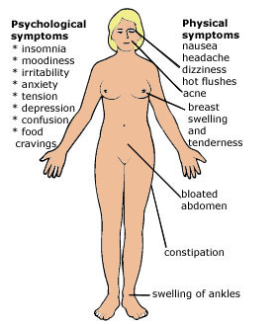
Symptoms of premenstrual tension
Treatment:
- Diet. Eat regularly and sensibly: eat small rather than large meals; avoid salt, caffeine and excess fluids.
- Exercise. Regular exercise often helps (e.g. swimming, aerobics, tennis).
- Relaxation. Plan to do things that you find relaxing and enjoyable during this time.
- Medicine. Examples of treatment used for premenstrual tension include vitamin B6 (pyridoxine), evening primrose oil and oral contraceptives (only by physician).

Painful breasts(121-126 )

Breast pain (known as mastalgia) has several causes. The main type of breast pain is cyclical mastalgia, which is a general breast discomfort that occurs in the second half of the menstrual cycle. It obviously is caused by a hormonal effect and is not harmful.
Other causes are:
- pregnancy or weight gain (not require physician contact)
- infection (after childbirth during breast feeding), tumors, certain drugs (estrogen and progesterone hormone therapies). This require physician contact.
- Note: Early breast cancer is usually painless, but all lumps need careful investigation.

Patient education:
Concepts:
-It is a very common problem, with about 2 out of 3 women complaining of breast pain at some stage of their lives.
-It is most common in the 30s and early 40s.
-Only 1 case in 200 will have cancer as the cause.
-continue to practice breast self-examination and report any lumps that do not go away after your periods with your doctor.
What are the symptoms?
It is usually a heaviness or discomfort in the breasts, while some women experience a prickling or stabbing sensation.The breasts may be so tender that relationships with partners and children are affected because hugging and fondling cause distress.

Treatment:
- Reduce weight if you are overweight: aim to keep at ideal weight.
- Reduce or cut out caffeine.
- Take mild analgesic for pain. Either systemic or topical creams
- Wear comfortable and supportive bras especially during sport activity.
- Apply a cool compress to your breasts.
- 'Natural' medication
Vitamins may help (although this is not scientifically proven):
- Vitamin B1: 100 mg per day
- Vitamin B6: 100 mg per day
- Evening primrose oil capsules: 4 g per day
Most women (85%) can be treated with natural methods.
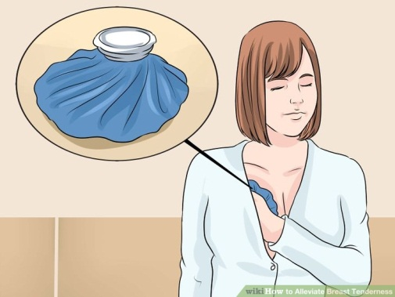

breastsSelf-examination (BSE) (127-132 )
Patient education:
Concepts:
Examine your breasts regularly and that you cover the breast area completely.
- This helpdetect any persistent lumps in the breast at an early stage of their development.
- Most breast cancers are found (as a lump) by the woman, not by the doctor.
- Early detection of a lump—if it is a breast cancer—may mean a better chance of a cure (may be 100%). By performing regular BSE, you are safeguarding your health.
- 1 in 15 women develops breast cancer at some time. So, BSE take minutes but save life.
- Breast examination should be done once a month a few days after the end of your period.
- BSE should be done by all women above the age of 20
- BSE do not replace regular mammogram for positive family history of breast cancer.

A-The common technique
*Position?
The breast tissue must be spread as flat as possible.
- Lie on your back with one arm behind your head. The right breast is examined by the left hand and vice versa.
Your examination must cover the breast tissue area completelyfrom about an inch down below the breast right up till the collarbone

*Vertical strips
Examine up and down the breast in vertical 'strips', beginning from the outer border. At the end of each strip, move the fingers about 2 cm towards the breastbone and examine another vertical strip.
*-Feel the breast with the flat of your fingers
Use the flat part of your fingers, including the fingertip pads, to feel the breast. Move your hand in slow, circular movements with both light and firm pressure.
B-Mirror examination:
Examine the size and the shape of breast in front of mirror in three different poisitions.
It is unusual for one breast to be larger than the other.

C-Nipple examination:
Examination of the nipple. Check to see if it’s harder or a different color from before and also for any kind of discharge.

What to look for?
If you find one of the following, make sure you see your doctor as soon as possible.
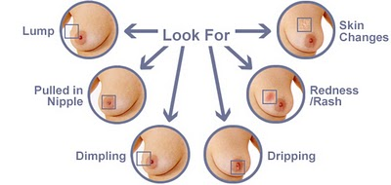

Priuritis vulvae(133-138)

Pruritus vulvae is both a symptom and a pathologic process affecting the vulva, Painful erythmatous vulva usually at young girls with insomnia, irritability

Patient education:
*Keep cool, especially at night time
*Wear loose fitting underwear and outer clothing
*Avoid nylon clothes
*Wash once or twice daily with medicated soap.
*Avoid scratching or rubbing the affected area
*Antihistaminic and topical steroids may be recommended. But, Do not apply strong steroid creams for more than a few days.
*adequate vaginal hygiene by regular use of vaginal Douching: Irrigation of vagina with a liquid possessing medicinal action it cleans, soothing, refresh & deodorizing vagina, applied once or twice weekly.

So on using douche, you should assure the following :
-Keep all equipment clean
-Do not use during pregnancy
-Do not use more than twice weekly
-Wait for 8 hrs post-intercourse in which spermicidal cream, jelly, or foam was used
-Wait for 3 days after using anti-fungal medication
- allergies may occur with Povidone/Iodine 0.3% (Betadine®) so only used for minor vaginal irritation or pruritis

Infertility(139-144 )
Infertility is the inability for achieving conception after a period of 12 months of normal unprotected sexual intercourse.
Sterility is the extreme case when conception can never occur.
Patient education:
Concepts:
-infertility is suspected after one year of no pregnancy.
-About 1 in 10 couples are infertile.
-The incidence increases with age, so that it gradually increases after the age of 32.

What is necessary for pregnancy to occur?
Three basic features are essential:
- The right number of healthy sperm has to be placed in the right place at the right time.
- The woman must be ovulating; that is, producing healthy ova (eggs).
- The tubes must be patent and the woman's pelvis sufficiently healthy to allow fertilization of the egg and then implantation in the uterus.
- psychological factors, such as stress, anxiety or adverse lifestyle

What can be done?
If a couple has not conceived in 12 months, they should both visit their doctor. At first the doctor will determine whether there is a sexual difficulty such as premature ejaculation. If a correctable condition comes to light, the couple will be given advice and told to try again for several months. If there is still a problem, the main tests that will be done are the sperm test in the male and the ovulation tests in the female.
The sperm test
The male is required to provide a sample of semen, after at least 3 days abstinence from sex. This fluid is placed in a clean bottle, kept warm and examined under the microscope within 1 hour.
Normal values are more than 3 mL with a sperm concentration of more than 20 million per millilitre and more than 60% normal forms and motility.
Ovulation tests
Ovulation can be worked out from the history of the nature of the periods, the cervical mucus and body temperature. Measurement of hormone levels in the blood on day 21 of the menstrual cycle will indicate whether ovulation is occurring.
Other special tests
If these tests are normal, there are many others (including special X-rays of the tubes and uterus of the female) that can be performed.
What is the outlook?
Current specialised treatment helps 60% of couples to achieve pregnancy.
The emotional trauma of infertility
Infertility is certainly associated with deep emotional problems that can flare up as crises from time to time. Unfortunately the emotional stress includes taking blame or placing blame on the other partner, and results in guilt feelings. Common feelings of infertile couples are denial and fear at first, and then frustration, anger, guilt, resentment, depression and loss of self-esteem. you should talk openly and honestly about your feelings and seek the help of a counsellor.

Eye problems in elderly(145-150 )
Many older people can maintain good eyesight into their 80s. However, natural physical changes can cause some problems with age. Older people generally need brighter light for everyday tasks such as reading, cooking and driving a car.

Patient education:
Concepts:
-Light bulbs are better than fluorescent lights.
-Have an eye examination every 2-3 years.
-Have regular checks for blood pressure and diabetes every 6-12 month.
-Eye problems tend to run in families.

Common eye complaints
1-Presbyopia
This is a common disorder first noticed after the age of 40 (usually 45 years onwards) when a change in the eye muscles and lens caused by loss of elasticity makes reading more difficult. You can read only by holding the material at arm's length. This applies to small print as in telephone books and street directories. It is a focusing problem, which is easily corrected by having reading glasses with a convex lens.
2-Excessive tears
Excessive tears are usually a sign of increased sensitivity of the eyes to wind, light or temperature changes. This complaint is very common in a cold wind. It can be minimized by wearing glasses, especially sunglasses, in those conditions.
If, no improvement with wearing glasses, it may indicate blocked tear ducts (lacrimal ducts) or an eye infection, and so physician contact is recommended.
3-Cataracts
A cataract is where the clear lens becomes cloudy or opaque and cuts down the light entering the back of the eye.
-deterioration of vision(blurred vision), glare to bright sunlight or during driving.
-They can occur in anyone but are more common in diabetics and those taking cortisone tablets.
-Cataracts can also run in families.
-They are diagnosed during an eye examination and require physician contact for treatment. A modern lens implant (an artificial lens placed in the space left by the cataract lens) can give excellent results.
-
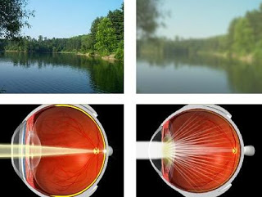

4-Dry eyes
This is caused by a reduced production of tears by the tear glands. It can cause many problems, such as scratching, itching, redness or burning. It is easily corrected by using artificial tears.

Redness of eye(151-156)

Red eyes are caused by enlarged, dilated blood vessels leading to the appearance of redness on the surface of the eye. May be caused by eye dryness, dust exposure, infection, allergic reaction, trauma. Also, straining or coughing may be a common cause of a red eye.

Patient education (for all age):
-Avoid dry air, sun exposure, dust, foreign body, an allergic reaction,
-Avoid trauma or infection by hand contact
-Avoid touching the infected eye and then rubbing the other eye as the infection can spread from one eye to the other.
-Apply cool or warm compresses throughout the day.
-Do not use contact lenses until the infection has cleared.
-Wash your hands frequently
-sun glasses may recommended to prevent recurrence
- OTC treated by the of use decongestant eye preparation like tetrahydrozoline (Visine®)with 72 hrs limit for use, unless contact physician.

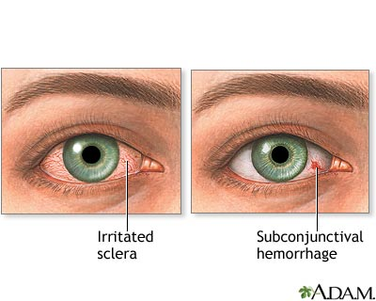

Stye (157-162 )

Inflammation or infectionof the sebaceous gland of the base of the eyelashes. More common in elderly.Causing pain, swelling, and tenderness of the eye lid.

Patient education (for all age):
-Stye does not take more than a week to heal.
-Even after that one has to be very careful with their hygiene habits so that the infection doesn’t recur
-Always wash hands properly with soap before touching or rubbing the eyes.
-Don't puncture or squeezestye yourself as it will spread the infection on other places of the eye
-Contact should especially take care of their eye hygiene (prevent infection spread).
-Wash your face at least 2-3 times every day, including the eye
-applying a very warm, wet, clean wash cloth to the tender area. This moist heat application should be done about four times a day, for about ten minutes at each treamtent.this speeds up the leukocytes' travel to stye.
-topical antibiotic eye ointment may be prescribed likechoroamphinicol eye ointment, Polymyxin B, erythromycin.

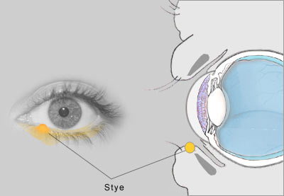

Hearing impairment in elderly(163-168)

Patient education
Concepts:
-Loss of hearing tends to gradually increase with advancing age. Every year after the age of 50 we lose some of our hearing ability.
-As many as 25% of people aged 60-70 report hearing impairment.
-In very old people, deafness can lead to unexpected behavioural problems such as confusion, agitation, anxiety, depression.
What are the symptoms?
The symptoms vary so that some barely notice a problem while others are severely disabled.
Common symptoms include inability to hear speech or to understand speech, even when it is loud enough (a problem of language reception)
People with mild hearing loss notice only have trouble hearing in certain situations, such as at a party or in a crowd where there is a lot of background noise.

What are the causes?
Hearing loss takes two forms: conduction loss, where the sound waves are blocked in their passage to the inner ear, and neurosensory loss, where the inner ear cannot pick up the sound waves properly and thus transmit them to the brain.
Causes of conductive deafness (usually reversible)
- Too much wax in the ears (cerumen impaction)
- ear infection
Causes of neurosensory deafness (usually not reversible)
- nerve damage
- exposure to loud noise, including sudden explosions
- certain drugs
- brain tumours
- presbycusis
What is presbycusis?
Presbycusis (pronounced 'prez-bee-ku-siss') is also known as 'old age' deafness and is the commonest type of hearing impairment in older people. It is caused by wear and tear in the inner ear. It does not cause total deafness but difficulties in understanding speech, especially with background noise with inability to hear high frequency sounds They often say 'Don't shout—I'm not deaf'.
What signs indicate that hearing should be tested?
- speaking too loudly
- difficulty understanding speech
- complaints about people mumbling
- requests to have speech repeated
- complaints of tinnitus
- setting television and radio on high volume
What can be done?
If medical problems such as fluid or wax in the ear are not present and 'old age' deafness is proved on testing, a hearing aid is usually fitted. There is no cure for the problem and hearing aids are not the perfect answer.

Cerumen impaction(169-174)

Cerumen is ear wax which is a mixture of secretion from the cerumen gland & sebaceous gland.
Patient education
symptoms:
-A feeling of fullness in the ear, mild pain in the ear, Difficulty hearing, which may continue to worsen, Ringing in the ear (tinnitus), A feeling of itchiness in the ear, Discharge from the ear (brown parts not watery) and Odor coming from the ear.

Treatment:
-The Use of cotton-tipped applicators May worsen impaction, so avoid their use.
-The healthy ear cleans itself through the continual outward migration of cerumen “known as ceruminokinesis”
-movements of Jaws on eating & talking facilitate ceruminokinesis so recommend gum chewing.
-Do not worry from partial hearing loss (temporary and reversible)
-removal of ear wax by ear cleaning every 6 months may be recommended.
-the use of drugs for wax removal may be recommended (organic solvent for wax) before ear cleaning
-if complete deafness contact physician
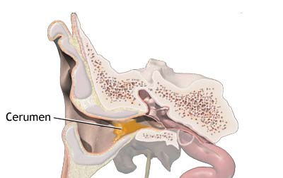

Traumatic rupture of the ear drum(175-180)

Perforated eardrum is a hole or rupture in the eardrum.
Patient education
Symptoms:
-Drainage from the ear (drainage may be clear, pus, or bloody)
-Ear noise/buzzing.
-Earache or ear discomfort.
-Hearing loss in the involved ear

Treatment:
-contact physician for examinations
-Protect ear from H2O or any ear drops.
-Reassurance for patients by confirming that most rupture heals spontaneously
-If adequate closure of the hole in the eardrum doesnot occur, drum is only responsible for 18 % of hearing.
-Avoid blowing nose forcibly.
-After rupture healing take cautions from the followingstrucking ear with an open hand , head trauma, from a sudden explosion, pushing object in ear.
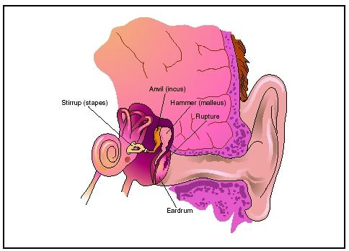

Tinnitus (181-186)

Tinnitus is hearing abnormal noise in the ear when there is no sound coming from the outside.

Patient education
-About 1 in 4 people are bothered by tinnitus, but it is a severe problem for 2% of the populationspecially elderly.
-Tinnitus in itself is not a serious condition, does not cause pain or deafness but can be frustrating.
-Tinnitus is less noticeable when there is background noise.
-The main problem is the psychological effect, as the noise tends to affect one's concentration, ability to think and peace of mind. Stress can aggravate the problem.
-It can also be a problem at night, when it is more noticeable and affects the ability to sleep.
What causes or aggravates it?
- Wax impaction
- ear disorders such as infection
- excessive noise exposure for a long time
- wear and tear of the ear with ageing
- stress and fatigue
- excessive alcohol
- smoking
- social drugs, including caffeine and marijuana
- head injury
What can be done for tinnitus?
After avoiding the risk factor as mentioned above, The following methods can help one cope with tinnitus:
A-Background sound treatment
A useful treatment, especially for those having trouble getting to sleep, is to have background music playing when retiring at night. Other sounds that are sometimes used include FM static produced by a radio set off the station and environmental sound masking tapes.
B-Tinnitus maskers
Some people are helped by wearing a tinnitus masker, which is a device like a hearing aid worn behind the ear. It produces a type of hissing noise that tends to counterbalance the tinnitus noise.
C-Distracting activities
Some people can cope by diverting their attention away from their tinnitus by keeping themselves busy and undertaking interesting activities that focus their mind elsewhere. Examples include gardening, power walking, music, television, handicrafts, jigsaw puzzles, card playing and discussion groups.

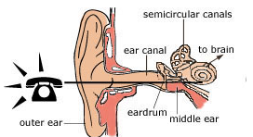

Ear: otitis externa (187-192)

The outer ear canal is a tunnel that runs from the ear hole to the eardrum. It is about 3 cm long and is lined with normal skin containing hairs and glands that produce wax. Otitis externa is a condition in which the skin lining the outer ear canal becomes red and swollen due to infection.
Patient education:
Concepts:
-This infection occurs commonly because of water entering the ear canal and is sometimes referred to as 'swimmer's ear”.
- The ear usually cleans itself naturally.
-Do not attempt to clean it and risk infection of the canal or damage to the eardrum.
What are the symptoms?
Pain and tenderness of the ear canal are typical, and in severe cases the pain and tenderness may spread to the outer ear and surrounding skin. Other symptoms include discharge from the outer ear canaland itching.
Why does it occur?
The outer ear canal is horizontal and curved; it may contain wax. Water may not drain freely and can cause skin to become soggy, so allowing bacteria or fungi, normally present on the skin, to cause infection.
Who is more prone to otitis externa?
-if your outer ear canal is narrow or long, or if the skin lining the canal is in poor condition (i.e. if it is not waterproofed by the wax and is wet by regular swimming).
-The skin lining will deteriorate too if it is prone to dermatitis or eczema
-The ear canal can be damaged by attempting to clean it with a hairpin.
What is the treatment?
Clean the canal and keep it empty and dry. In mild cases, your doctor will treat the infection by cleaning the outer ear canal using suction and then prescribing cream or solution to insert several times a day. The ear cream is used for about 5 days and contains chemicals that kill the bacteria or fungus causing the infection.
-If the infection is severe and the outer ear canal is swollen, contact the doctor as he may insert a cotton wick coated with the healing cream into the ear canal.
How can otitis externa be prevented?
-If water enters, shake it out.
-Avoid getting water in your ear.
-Use moulded earplugs or a bathing cap when swimmingshoweringor washing your hair.
-Avoid poking objects such as hairpins and cotton buds in the ear to clean the canal.

Halitosis (193-198)

Halitosis is unpleasant smelling or 'bad' breath. It is common in healthy people, especially in the morning when they first awaken from sleep.

Causes:
-Dental problems, poor oral hygiene, food residue, coffee and tea drinking or smoking
-systemic causes Ex: D.M., hepatic disorders or renal disorders, tonsillitis, sinus infections, lung disorders (e.g. TB and bronchiectasis), cancer, general infections with fever (e.g. glandular fever) - Gases from the stomachdue to the breakdown of some foods. Foods that tend to cause problems are onions, garlic, peppers and strong cheeses.
-stress, and habitual mouth breathing, which dries saliva in the mouth
Dental problems
Halitosis is mainly caused by dental problems, usually tooth decay or plaque and food trapped in the gaps between the teeth. The bits of food undergo decay by bacteria, just like food left to rot, and this process causes an unpleasant smell.
Another common dental problem is inflammation of the gums (gingivitis), which is usually caused by dental plaque at the base of the teeth as we get older. The gums tend to be sore and bleed on brushing.Plaque and gingivitis often appear together, and both contribute to halitosis.
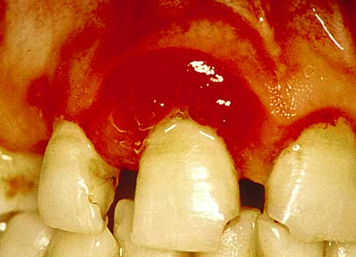

Patient education for oral hygiene :
Concepts:

-Brush the teeth regularly during the day, immediately after each meal if possible.
-Rinse the mouth out with water after meals.
-Use dental floss each day to clean the teeth.
-Gargle with an antiseptic mouthwash (e.g. Listerine, Cepacol).
- Gingival diseases are more common in tobbacco smokers which worsen deposition of plaques
-Avoid hard brush as it may damage gingiva & abrade the softer cementum of the root producing nerve damage so unless advised by a dentist, choose the softest or medium brush.
-soft brush is recommended for week teeth with bleeding
-hard brush is recommended for smokers to remove sticky tar.
-Brush after meals and at bed time are recommended for caris prevention
-F⁻ is contraindicated in children lower than 2 years
-Tooth brush can be a media for bacterial growth due to warm bathrooms and food particles from mouth. So recommend to change brushes every 1 M – 3 M or alternate between 2 or 3 brushes to allow for brush drying.
-Whitening tooth paste act by abrasion to remove dental plaques & stains, but it may damage enamel by abrasion.
-Avoid acidic food or drinks can erode enamel and uncovers the nerve”.
-donot store several toothbrushed in the same cup (bacteria transmission)
-microwave sterilization of the brush is recommended for 1 minutes

What are the effects?
It is not a serious problem, but it can seriously affect the personal and social life including their self-esteem. So, the advice is to improve oral hygiene, avoid precipitated foods like onion, avoid smoking and coffee intake.
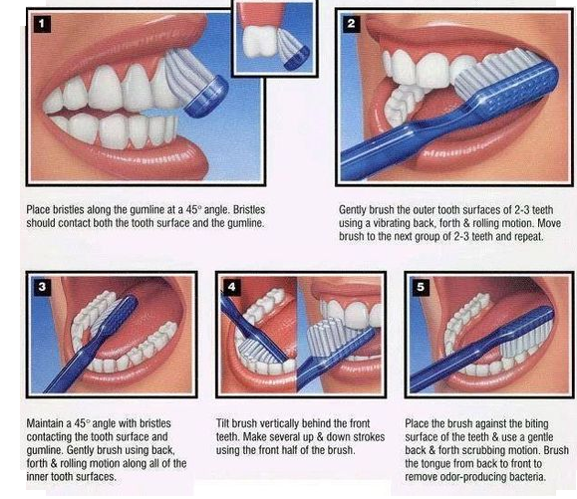

Heartburn (GERD)(199-204)

It refers to heart burn from back movement of stomach contents into the esophagus (Not in the mouth unless it becomes vomiting).Heartburn is not a disease but a symptom of burning discomfort in your chest, usually associated with an acid taste in the mouth. It is associated with drinking and eating.

Patient education:
Concepts:
-Avoid Over eating of food as affect lower esophageal sphincter (LES) tone.
-Avoid foods that irritate esophagus (Acidic food or hyperosmolar food “orange, Milk, tomato”).
-Avoid carminative as peppermint induce reflux by impair LES function.
-particular foods (e.g. cabbage, onions, cucumber, curries, pastries—especially pies and pasties, fruit cake)
-Avoid eating too fast. Eat in a slow and relaxed manner.
-Avoiding eating standing up.
-Avoid chewing gum long and hard
-avoid stress and anxiety
-avoid eating spicy foods.
-Avoid certain drugs (e.g. antirheumatism drugs, aspirin)
-avoid obesity (a common factor)
-Avoid tobacco (lower LES pressure).
-avoid drinking too much caffeine (tea and coffee) increase acid and burn sensation.
-Last meal should be light 3 – 5 hr before bedtime
- weight reduction if obese

Management:
- OTC drugs can be given by pharmacist. This includes antacid, low doses of H2 blockers or PPI but take care of the following:
- avoid Na containing antacid of hypertensive patients
- Tablets should be chewed thoroughly to obtain optimum effects.
- Tablets should be taken after meals as will neutralize stomach acids upto 3 hrs
- H2 blockers Tablets should be taken before meals by 30 – 60 min at breakfast & bed time
- PPI shouldnot be use more than 2 months as it may cause gastric tumor secondary to a chlorohydra.
- if it persists or with bleeding, contact my doctor is concerned about an ulcer, X-rays may be taken or a tube called a gastroscope may be passed down into the stomach to inspect it.

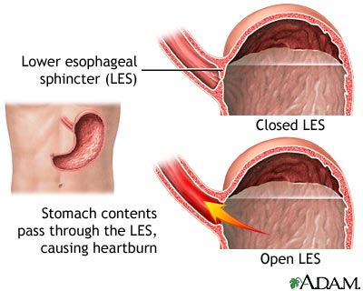

Motion Sickness(205-210)

It refers to nausea & vomiting on long travel. (Neuronal mismatch theory) in which input from visual system mismatch input from vestibular system (in inner ear).

Patient education:
Concepts:
- The longer the motion, the more likely the symptoms
-Avoid reading in car & ships.
-Shift the field of vision to objects out side vehicles.
-Nearly all children grow out of the tendency to have travel sickness
-The larger the boat, plane or car, the less is the likelihood of sickness; travel by train rarely causes sickness.
-Keep calm and relaxed before and during travel.
-With children, avoid excitement and apprehension about the travelling.
-Lie down, if possible, because this rests the inner ear canals and reduces the urge to vomit.
-If travelling by car, stop regularly for breaks.
-Passengers should use the front seat if possible.
-Do not have a large meal a few hours before the journey or during it; avoid milk and fried or greasy foods.
-do not drink too much. Glucose drinks such as lemonade are suitable, as are glucose sweets and biscuits while travelling.

Management:
Medication
-OTC Drugs like Antihistaminic drugs Cyclizine (Emetrex)® and Dimenhydrinate (Draminex)® should be taken 30-60 min before trip.During a long trip this can be repeated 3-4 times a day to prevent the symptoms. These medicines may make you drowsy, so take care

Skin patches
Scopolamine adhesive patches are the most widely used medication for long-term travel, especially sea travel. One patch should be applied to dry unbroken hairless skin behind the ear 5-6 hours before travel. It should be left on for 3 days but removed immediately the trip is over.

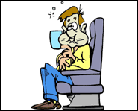

Bloating & Flatulence(211-216)

Excessive intestinal gas leading to abdominal swelling and cramping

Patient education:
Concepts:
-avoid gum chewing & smoking
-avoid milk and dairy products (Lactose intolerance)
-avoid Legume ingestione. g: beans which contain indigestible oligosaccharide which in colon converted by bacteria to gases.
-Eating while lying down prevents gas from escaping from G. I. T. so avoid eating in lying down position.
-Rapid eating causes more air to be swallowed, so advice patient to eat slowly & masticate food thoroughly .
-people with dental problem are more suspected to bloating, so treat you dental problem.
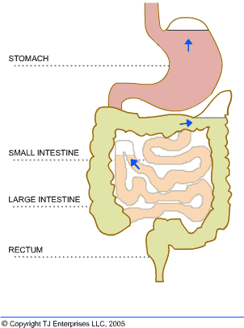

Constipation(217-222)

Constipation is hard, often very small stools with infrequent bowel movements or a feeling of unsatisfied emptying of the bowel. Often with pain, straining on defecation.
Patient education:
Concepts:
-Bowel regularity can vary from person to person.
- maintain your bowel habit
-Many laxatives can actually aggravate the problem in the long run and should be avoided.
-If absolutely necessary, your doctor may recommend one of the hydrophilic bulk-forming agents
-- avoid traveling or sitting in cars for hours (doesn't permit exercise).
-recommend high fluid intake.
-decrease food contains low fibers like e.g. (ice cream – meat – cheese, )
-No laxative should be given to children lower than 2 years due to dehydration risk (give glycerin suppositories if needed) which act in 15 – 60 min.
- Avoid Medications like Iron, AL +3 antacid, NSAIDs as ibuprofen,
-All laxatives are avoided in pregnant except bulk laxative

What are the causes?
It is mainly caused by simple things such as:
- neglecting the habit of attending the toilet
- not responding to 'nature's call'
- overuse of NSAIDs
- a poor diet with a lack of fibre
- lack of exercise
- insufficient fluid intake
- secondary to some diseases like thyroid, DM, depression, bowel cancer

What are the risks?
Constipation can cause a lot of discomfort in the stomach and rectum. It can lead to herniasand problems of the anus such as piles and anal fissure.
Recommendation:
- Habit: Maintain or make regular bowel habit
-Activity:Adequate exercise, especially walking, is important.
-Diet:Take plenty of fluids, especially water and fruit juices. Eat foods that provide bulk and roughage, for example vegetables and salads, cereals (especially bran), fresh and dried fruits. Some examples of food with good bulk (from least to most) are potatoes, cauliflower, peas, cabbage, lettuce, apples, carrots and bran.

Anal fissure (223-228)
It is a crack or tear at the margin of the anus that extends from the skin into the soft lining of the anus. It can affect all ages and tends to occur in women and infants.
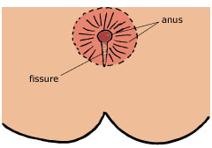
Patient education:
What are the symptoms?
- sharp, often severe pain on opening the bowels. The resultant pain can last for several minutes and up to an hour.
- pain or discomfort when sitting on a hard surface
- spots of blood on the toilet paper or underwear
What causes an anal fissure?
The tear, which is generally small, usually develops after stretching of the anus from passing a hard, large stool. It is associated with constipation, and multiple pregnancies.
What about infants?
Anal fissures in children usually occur with constipation, and possibly result in refusal to defecate. Recovery usually occurs quickly if the stool is softened. Treatment includes applying a local anaesthetic ointment to the anus whenever the child shows a desire to defecate, until healing occurs.
What is the usual outcome?
Adults usually recover in about 4 weeks, especially if the fissure is small. More severe cases may require a small operation.
How can anal fissures be prevented?
The secret is to avoid constipation
Some people may find it necessary to use bulk laxatives.
What is the treatment?
- Prevent constipation; keep the stool soft.
- Gently clean the anus with cottonwool and warm water after each bowel movement.
- Take a warmbath for about 20 minutes twice a day.
- Take analgesics such as aspirin or paracetamol for pain.
- Apply zinc oxide ointment around the anus to soothe the area.
- A special ointment containing local anaesthetic to relieve discomfort.

Haemorrhoids (piles)(229-234)

They are conglomerates of blood vessels overlying skin of anorectal area or may be considered distended veins of hemorrhoildal vein plexus which can prolapse outside the anus and hang as small grape-like lumps.
Patient education:
What are the different kinds of haemorrhoids?
Internal haemorrhoids are those that form inside the rectum near the beginning of the anus. They are generally not painful and often are only noticed when they bleed.
Prolapsed haemorrhoids are internal haemorrhoids that protrude through the anus when the stool is passed or when a person stands or walks. They are usually painful.
External haemorrhoids are small, painful haemorrhages under the skin around the anus. They form a hard clot after 24 hours. Their proper medical name is perianal haematoma. When they settle, they sometimes leave a small skin tag.
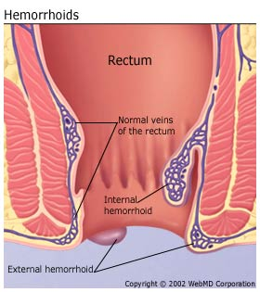
Classification of hemorrhoids :
-First: Enlarged hemorrhoids but no prolapse.
-Second: Bleeding & prolapse on defecation but return spontaneously.
-Third: prolapse with bowel movement & standing, can be returned by manual manipulation.
-Fourth: prolapse irreducibly, thrombosing, profuse bleeding & great pain.

What causes haemorrhoids?
-The commonest cause is constipation, mainly due to the excessive straining at toilet because of hard feces.
-The problem tends to run in families.
-Other associations are heavy manual work, sitting for long periods (such as bus driving) and pregnancy.
How common is the problem?
Haemorrhoids are common and tend to develop between the ages of 20 and 50. About 1 out of 4 Westerners suffer from them at some stage of life.
What are the symptoms?
Bleeding is the main symptom. The word haemorrhoid means 'flow of blood'. The blood is bright red and appears when you defecate. You may notice it as streaks on toilet paper or in the feces.
Piles often cause a mucous discharge and itching around the anus.
What are the risks?
Haemorrhoids are not dangerous, but continuous bleeding may result in anaemia. Any bleeding from the anus, especially in someone over the age of 40, should be reported to your doctor.

What is the treatment?
-The best treatment is prevention by constipation avoidance.
-Train yourself to have a diet with adequate fibre by eating plenty of fresh fruit, vegetables, and whole-grain cereals or bran.
-Try to complete your bowel action within a few minutes and avoid straining.Don’t spend too much time attempt to defecate, if defecation doesn't occur in 5 minutes.
Washing anal area with soap & H2O after each bowel movement

-Recommend warm bath By sitting in worm water 2 – 3 times daily for 15 – 30 min each bath. This relieves symptoms.

-Special astringent ointments or suppositories may relieve the congestion and shrink the haemorrhoids. Mild cases may clear up completely.
-Products intended for external use shouldn’t be placed into rectum -by mistake-with fingers or with applicators, unless systemic toxicity may occur.
-If the problem persistsor bleeding occure, your doctor may advise injections or minor surgery. Occasionally surgery to remove the piles—called haemorrhoidectomy—may be the only answer.

Diarrhoea(235-240)
Diarrhoea is the passage of many loose, watery, offensive bowel movements. It is a symptom, not a disease. It is usually associated with colic-type abdominal pain and vomiting. It is a self-limiting problem.Diarrhoea usually is caused by a viral or a bacterial infection.
Patient education:
Concepts:

-Most episodes last for such a short time that a search for the cause is not necessary.
-However, if it lasts for 12 hours or longer, medical attention is needed. If it is associated with fever and the passage of blood and mucus—it requires close attention.
-Avoid Cow’s milk for infant.
-avoid Medication like colchicines, Antibiotics (ampicillin).
-improve personal hyegine like hand washing before eating
--diarrhea may be self-limited
- Rehydrin solution does not affect diarrhea frequency or duration but only replace electrolyte.
Recommendation:
Rest:
Your bowel needs a rest. It is best to reduce your normal activities until the diarrhoea has stopped.
Diet
-It is vital that you starve but drink small amounts of clear fluids such as water, tea, lemonade until the diarrhoea settles. Then eat low-fat foods such as stewed apples, rice (boiled in water), soups, poultry, boiled potatoes, mashed vegetables, dry toast or bread, biscuits, most canned fruits, jam, honey, jelly, dried skim milk or condensed milk (reconstituted with water).
-Avoid alcohol, coffee, strong tea, fatty foods, fried foods, spicy foods, raw vegetables, raw fruit (especially with hard skins), and cigarette smoking.
-On the third day introduce dairy produce such as a small amount of milk in tea or coffee and a little butter or margarine on toast. Add also grilled lean meat and fish (either grilled or steamed).
Medication
-Diarrhoea usually settles without the need for medicine. So, rehydration solution may be enough.If it is socially embarrassing, kaolin-based preparations can help.
-drugs that inhibit GIT Motility Loperamide (Lopodium, lmodium)® or Disphenoxylate (Lomotil)® as they increase the spreading of infection (diarrhea act to wash the M.O.)
-Antibiotics mainly include sulfa drugs or according to the infection type.

Irritable bowel(241-246)

Anirritable bowel (also known as irritable colon) is one that does not work smoothly and causes abdominal problems such as colicky pain and disturbed bowel actions. The bowel is a muscular tube that propels the food along in waves (called peristalsis). This muscular action may become overactive and cause spasms or tight contractions rather like a cramp in the leg muscles.
Patient education:
What are the causes?
There is no clear-cut proven cause but the main factor is considered to be emotional stress. Other possible causes are:
- infection of the bowel
- food irritation (e.g. spicy food)
- food allergy (e.g. milk)
- overuse of laxatives
- pain-killing drugs and antibiotics
What are the symptoms?
The main symptom is a cramp-like pain in the abdomen (in the center or lower left side). Diarrhea or constipation may occur, and You may also feel mildly bloated or flatulent (windy).

How common is it?
At least 1 person in every 100 has it, and many simply learn to live with it.
What are the risks?
The irritable bowel is harmless, but may carry out investigations to ensure that there is no disease in the bowel.

What is the treatment?
Self-help:
-If you recognise stresses and strains in your life, try to develop a more relaxed lifestyle.
-Try to avoid any foods that you can identify as causing the problem.
-You may have to cut out smoking and alcohol. A high-fibre diet may be the answer to your problem.
Medical help
If self-help measures are not controlling the problem, take medicine to settle the painful spasm of an irritable bowel. Like librax® or spasmodigestin®

Backache(247-252)
Patient education:
Concepts:
-back pain can be a symptom of other systemic disorders like urinary or prostate disorders. So exclude these first by asking for other accompanying symptoms.
-Backache usually is caused by minor strains in the muscles or ligaments
-The more serious lower back pain usually is the result of an injury that usually happens while bending your spine forwards (flexing it), especially while lifting something heavy.
Recommendation:
-Never bend forward with your legs straight to perform any task. Once you have experienced back trouble, it has a tendency to recur, and so be careful to protect your back.
-Adjust your activity to your back discomfort. Take care with posture, making beds and so on.
- applying ice to injured back is recommended.
-Avoid fatigue. Ideally you should perform a set of exercises to strengthen the muscles of your spine and abdomen.
-Sport: Be careful of sudden twisting movements of muscles, as in cricket, golf, squash, sailing, and weightlifting.
-Sitting: Avoid sitting for long periods, especially in the car or in front of TV. Your knees should be higher than your hips and your back straight.
-Bed rest and sleep: Use a low pillow and lie on your side orface-up. Use a firm mattress.
-Lifting: Avoid lifting anything heavier than 10 kg (20 lb). Squat close to the load and keep your back straight not bent forwards or backwards.
-Obesity: Being overweight adds an extra burden to your back, so it is important to keep as close to your ideal weight as possible.
-Acute episodes of pain: It is best to keep active and keep up your normal mobility (if possible) when your back hurts. If the spasms are severe, you will need to lie down on a firm surface.
-Bending: Take care when bending, for example tying shoelaces or putting on stockings. Put your foot on chair or box that is near enough to your body and high enough so that you do not have to bend down to your foot.
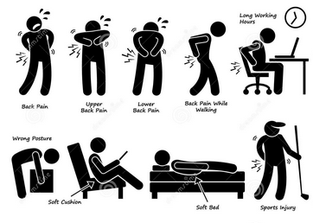
How to Lift Safely
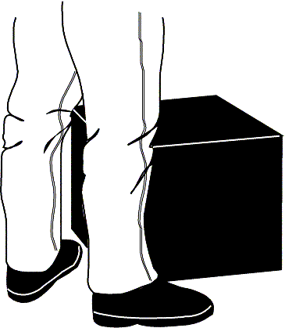 | 1. S1-tand close to the load with your feet spread apart about shoulder width, with one foot slightly in front of the other for balance.
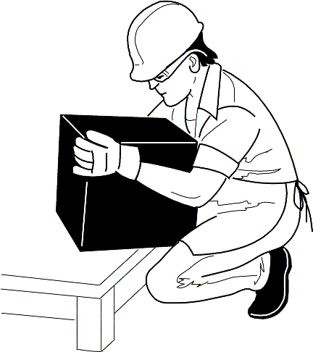 | 2-Squat down bending at the knees (not your waist). Tuck your chin while keeping your back as vertical as possible.
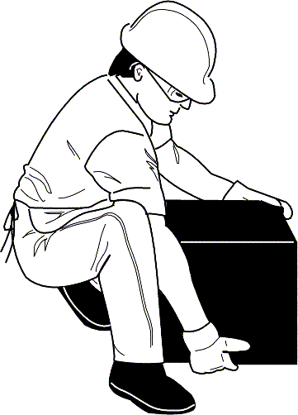 | 3-Get a firm grasp of the object before beginning the lift.
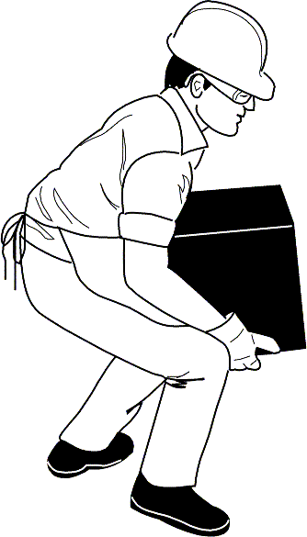 | 4- Begin slowly lifting with your LEGS by straightening them. Never twist your body during this step.
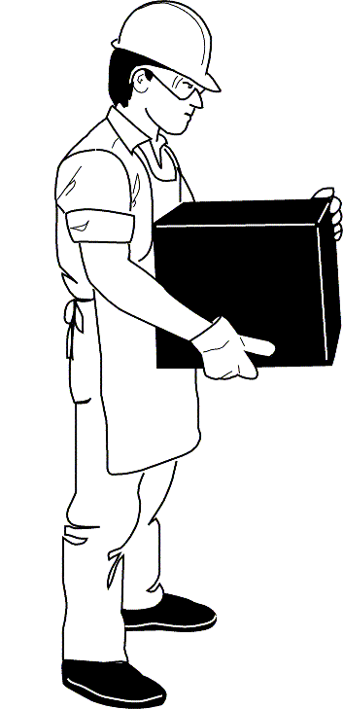 | 5- Once the lift is complete, keep the object as close to the body as possible. As the load's center of gravity moves away from the body, there is a dramatic increase in stress to the lumbar region of the back.

Carpal tunnel syndrome(253-258)
It is a painful disorder of the hand caused by pressure on a very large nerve called the median nerve as it passes through a 'tunnel' at the wrist.The tunnel is formed by a tough membrane that makes a 'roof' to a natural arch produced by a group of wrist bones (known as the carpal bones). The purpose of this membrane is to keep the many tendons, arteries and nerves that pass under it in place. When it thickens, it causes too much pressure on these structures, especially the sensitive nerve.
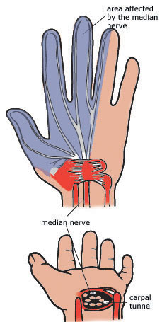
Patient education:
Concepts:
-It is quite a common disorder, especially in middle-aged women and in pregnant women. It is thought to be caused by hormone changes causing swelling of the membrane and extra fluid in the tunnel.
-People doing a lot of hard manual work (such as farmers or housewife) seem prone to carpal tunnel syndrome.
-Sometimes an illness such as rheumatoid arthritis may cause it.
-It is not a serious problem, but if not treated it can cause permanent weakness and numbness of the thumb and index and middle fingers.
What are the symptoms?
The symptoms are tingling and numbness of most of the hand. The little finger is usually free of symptoms. One or both hands may be affected. The pain and tingling is usually worse at night and causes you to wake from a deep sleep. It may be relieved by hanging your hand over the side of the bed and shaking or rubbing it.
What is the treatment?
-Sometimes the problem clears up without treatment just decrease manual work by hand. In pregnant women once the baby is born the problem usually cease.
-Vitamin B complex injection can reduce numbness.
-An injection of cortisone into the tunnel can give dramatic relief for quite a long time, especially in people with rheumatoid arthritis only by physician.
-In severe cases, this require a small operation to relieve the pressure on the nerve. This is done by cutting through the tough membrane so that more space is created for the nerve in the tunnel. It is a most successful operation, leading to immediate relief of the discomfort.

Painful neck(259-264)
it is a pain and stiffness in the neck.Pain in the neck is commonly the result of an injury of the neck as in a motor vehicle accident. Other causes include blows to the head (such as in boxing and wrestling). Also, an unusual twist in the neck for a long period during sleep or in front of computer. In older people, arthritis can develop in these joints.
Management
Neck pain, which is rarely a severe problem, can clear up very quickly and usually responds very well to physical treatment such as exercises, massage (physical therapy). However, it can be persistent or recurrent, and for that reason regular exercise of your neck is advisable.Mild analgesic may be prescribed for pain.
To avoid recurence of further neck pain, the following rules are helpful:
keep your neck upright in a vertical position (do not bent knee) for reading, typing
- keep a good posture ( do not look up in a strained position for long periods (e.g. as when painting a ceiling)
- sleep on a low, firm pillow
- sleep with your painful side on the pillow
- use heat and massage: massage your neck firmly 3 times a day using an analgesic ointment
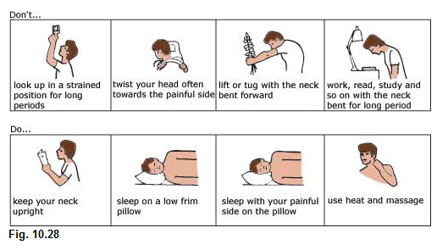
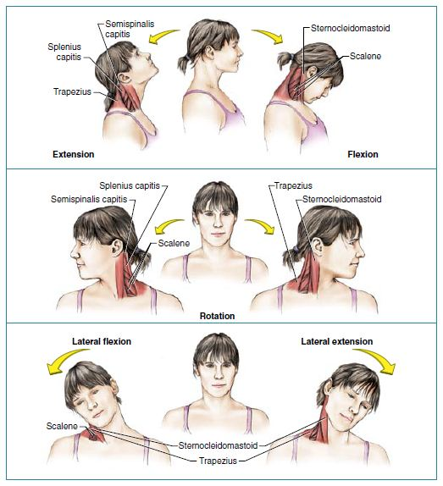
Neck exercise chart

Sciatica(265-270)

Sciatica is a type of neuralgia (nerve pain). The sciatic nerve is a huge nerve (about the size of an adult's small finger) that controls the function of the leg, especially the foot. It passes from the spine into the buttock, then into the back of the thigh and leg.
Patient education:
Concepts:
-This problem is quite common in elderly and obese people.
-lifting, bending your back and sitting in soft chairs for long periods may precipitate acute attack.
-Rest on a firm mattress or on the floor
-Exercises like swimming may be recommended
-the improvement may take 6-12 weeks

What causes sciatica?
It is caused by pressure, usually from a prolapsed disc, on the nerve roots from the lower back that form the sciatic nerve. This problem is often called a 'slipped disc', but it is not a good term because the disc is big and only part of it bulges to cause pressure. Also from surrounding disc arthritis.

What are the symptoms?
The patient usually feels a burning pain or a deep aching pain in the buttock, the thigh, the calf and the outer border of the leg, ankle and foot. The pain may vary from very severe to mild. A 'pins and needles' sensation or numbness may be felt in the lower leg and the foot.
The pain is usually made worse if you sneeze, cough, or lift something.
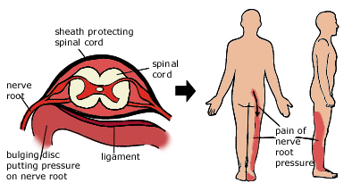
Recommendation:
*Fortunately most cases of sciatica gradually get better in about 6-12 weeks.
*Rest: When the pain is acute, it is most important to rest lying down for 2 or 3 days if you cannot cope. Rest on a firm mattress or on the floor. After the acute phase, Avoid lifting, bending your back and sitting in soft chairs for long periods.
*Analgesic and pain killer may be given for acute pain
* physical therapy program may be recommended.
*Sometimes the pressure on the nerve is so great that the leg, especially the foot, becomes weak. In such cases, an operation is required to relieve the pressure.
*Exercise like swimming is recommended and lower back exercise is recommended as mentioned
* spine brace may be recommended.
Exercises for the lumbar spine:
The purpose of these exercises is to strengthen the various muscles that support the spine, especially the abdominal muscles and the extensor muscles of the spine.Back exercises are extremely important because the muscles of the spine and abdomen support the spine better than any brace
Patient education:
Concepts:

-Do these exercises on a padded or well-carpeted floor.
-Do them at least twice a day for no less than 5 minutes at a time.
-Rest between each exercise.
-The exercise may be uncomfortable at first, and initially each one should be repeated only 2 or 3 times. As the muscles stretch and strengthen, the routine becomes more natural and enjoyable.
-If there is any problematic pain with a particular exercise, stop doing it.
Exercise 1: Back arch
Stand up straight, feet pointing directly forwards and apart as wide as your shoulders, hands placed on the small of your back, fingers pointing backwards. Breathe in and breathe out slowly. As you breathe out, bend backwards as far as you can while supporting your back with your hands and keeping your knees straight. Hold your lower back arched for 5 seconds, then return to the neutral position. Repeat 5 times.
Exercise 2: Knee-to-chest raise
Lie flat on your back, bend one leg up, grasping it with your hand just below the knee, and bend your head forward so that your forehead approaches your knee. Hold for 5 seconds. Repeat on the other side.
Exercise 3: Straight-leg raise
Lie on your back. With your leg perfectly straight, raise it as high as you can. Repeat with the other leg. Take this to the limit of pain.
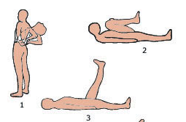

Bell's palsy(271-276)
It is a condition where the muscles on one side of the face become paralysed because of defect in the nerve (called the facial nerve or cranial nerve VII) that controls those muscles. The facial nerve leaves the brain through a very small hole in the base of the skull near the ear. The nerve becomes swollen, and because of the tight fit in this hole it does not work properly.
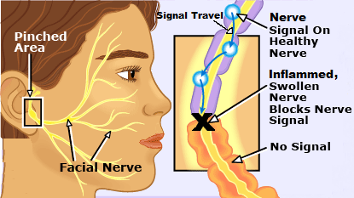
Patient education:
Concepts:
-We are not certain what causes this problem, may be viral rapid change in temperature
-Bell's palsy is usually not a serious or permanent problem. At least 90% make a good recovery.
- It can occur at any age, but is most common in young adults.
-The palsy usually recovers without special treatment. but a course of antiviral or steroid tablets may be prescribed to fasten the recovery.
-it take about 6 month to recovers
- Keep a positive outlook on life will fasten the recovery
What are the symptoms?
The main symptom, which comes on quite suddenly (maybe overnight), is weakness of one side of the face. The corner of the mouth droops, the eye cannot close properly and actions of the face such as smiling and frowning look out of shape. Some ear pain may be felt just before the problem develops.
Recommendation:
Continue your normal activities, but choose a good lifestyle by getting plenty of rest and sleep, avoiding smoking and excess alcohol.

Care of the eye: If your eye cannot close fully, it is important to protect it from injury such as dust by wearing glasses and putting a patch over the eye at night.
Massage and exercises: Massaging and exercising the facial muscles may fasten the recovery. Using oil or cream, massage the muscles of the forehead, cheek, eyes and lips. Exercise these muscles in front of a mirror by screwing up the eyes tightly to close them, smiling widely( require physical therapist).
Heat treatment:If you have pain in the face, apply heat 3 times a day to the painful area.
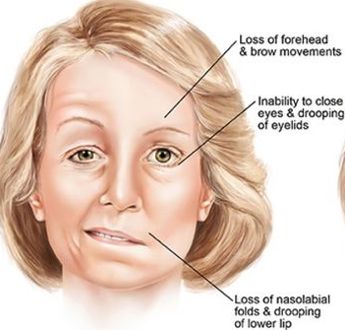

Hypertension(277-282)

The higher the blood pressure, the greater the risk of cradiovacular risk factor.

Patient education:
Concepts:
-Regular checks yearly for people over 40 years, are advisable
-Doctors recommend that you have the diastolic level (lower level) of blood pressure kept at 90 mm or below.
-hypertension is a controllable not curable disease.
-blood pressure is not determined by the way the patient feel as it is asymptomatic disease mainly. It is determined mainly by blood pressure measurement
- decrease salt intake,
-weight reduction and regular exercise is recommended
- avoid of smoking, dietary fat.
- control ofcaffeine (tea or coffee)
-during blood pressure measurement, ensure the followingcorrect BP monitoring:
- Do not measure BP just after physical activity.
- Do not smoke, talk, and move during the test.
- Rest quickly for 3-5 min. Before the test

Cholesterol: how to lower cholesterol(283-288)
Heart disease is the number one killer in the world. It is mainly caused by clogging up of the arteries by a fatty substance known as atheroma, which comes from having too much 'fat' in the blood. This serious process is called atherosclerosis—the condition that can lead to heart attack or stroke. There are two types of fat that cause damage if their levels are too high—cholesterol and triglyceride. A special blood test taken after fasting for at least 8 hours can tell if one or both of these fats are too high.
Triglyceride
If your triglyceride level is too high, fixing the problem is usually quite straightforward because it is mainly due to being overweight. It is caused by having too many calories in the diet, especially from sugar and other carbohydrates and high-calorie drinks (e.g. soft drinks and alcohol, in particular beer). The aim is to get your weight down to an ideal level.
Cholesterol
High cholesterol is a bigger problem, and if your level is too high it is important to reduce it. Most people can lower the level through changing their diet. Occasionally the level is so high in some people that, in addition to the diet, special medicine is necessary to reduce it to the right level. The prescribed drugs are very effective.
Note: Although cholesterol is present in animal food, it has been shown that it is necessary to reduce the amount of all the saturated fats (plant and animal) in our diet and to lose excess weight in order to get our cholesterol down. Foods rich in starch (such as bread, rice and pasta) and fibre also help.

Patient education:
Concept
- Keep to your ideal weight.
- Take a high-fibre diet.
- Eat fish at least twice a week.
- Beware of 'fast' foods.
- Avoid deep-fried foods.
- Take regular exercise.
- Always trim fat off meat.
- Avoid biscuits between meals.
- Drink more water.
- Do not smoke.

The low cholesterol diet(289-294)

 | Foods to avoid | Suitable foods
Eggs | whole eggs, egg yolks | egg whites
Milk | whole milk and its products—butter, cream, cheese, ice-cream, yoghurt, condensed milk | low-fat milk, skim milk and its products—cottage and ricotta cheese, buttermilk, non-fat yoghurt
Organ meats | brains, liver, kidney, sweetbread | —
Seafood | squid (calamari), caviar, fish 'fingers', shrimps, canned fish in oil (e.g. sardines) | fresh fish, scallops, oysters, canned fish in water
Meat | fatty meats—canned meats, pressed meats, meat pastes, hamburger mince | rabbit, lean cuts of beef, and lamb
Poultry | duck, goose, skin of chicken and turkey, pressed chicken | chicken, turkey (lean and without skin), preferably free-range
Bakery food | pies, pasties, pastries, cakes, doughnuts, biscuits | bread, crisp breads, water-biscuits.
Fast food | fried chicken, chips., hot-dogs, pizzas, fried rice | —
Nuts | cashews, coconut, roasted nuts, peanuts, peanut butter | hazelnuts, walnuts, almonds
Fruit and vegetables | — | all types (very important)
Miscellaneous | caramel, chocolate, butterscotch, fudge, coffee whitener and other cream substitutes, | rice, pasta, cereals, jelly, herbs, canned spaghetti, Vegemite, tea, coffee, honey, jam.
Oils and fats | saturated fats | polyunsaturated fats: vegetable oils—olive, walnut, corn, soya bean, sunflower
Cooking methods | frying, roasting in fat | using vegetable oils (as above), baking, boiling, grilling, stewing

Diet guidelines for good health(295-300)

The following recommendations come from authorities on nutrition, such as NIH. These guidelines ensure an adequate intake and balance of all important nutrients—carbohydrates, proteins, fats, fibre, vitamins and minerals.
Patient education:
Concepts:
- Do not eat animal meat every day, and then eat small portions.
- Limit tea and coffee intake.
- Eliminate or reduce takeaway foods (high in salt and fat).
- Eat fish at least twice a week.
- Plant food is good for you.
- What you usually eat matters most, not what you occasionally eat.

1. Eat less fat
Select fish, poultry and lean meats; trim excess fat from meat and the skin from poultry. Limit the amount of butter or margarine on vegetables and bread. Use the minimum of cooking fats. Limit the intake of full-cream products, fried foods, fatty takeaway and snack foods.
2. Eat less sugar
Avoid or reduce sweet foods such as sugar, soft drinks, syrups, biscuits and cakes. Reduce the sugar in recipes. Use fresh fruit instead of canned fruit.
Instead, increase your intake of complex carbohydrates that contain starch and fibre. Eat more wholegrain breads and potatoes prepared without added fat.
3. Eat more breads and cereals, fruit and vegetables
Eat more fruit and vegetables, including dark-green vegetables, potatoes and corn. Choose wholegrain products—cereals, bread, bran, rice and oatmeal.
4. Use less salt
High sodium intake may raise your blood pressure. Use few salty processed foods, including canned vegetables, meats, chips, crackers, and sauces. Read labels on canned and packaged foods for their sodium content. Use little salt for cooking and at the table.
5. Drink more water
Use water in preference to soft drinks, coffee and tea, juices. Use water filters and purifiers if your water supply is not pure.

Obesity: how to lose weight wisely?(301-306)
Why bother to lose weight?
You will look and feel so much better—your self-esteem will return. It will reduce your risks of heart disease, stroke, diabetes, cancer, gall bladder trouble, hiatus hernia, high blood pressure and arthritis, especially of the hips and the knees. Taking your obesity into old age creates many uncomfortable problems.

Rule:
-If we eat more fuel (joules) than we burn, we get fat.It is essential to cut down on high-calorie foods. These include:
- fats (e.g. oils, butter, margarine, peanut butter, some nuts)
- refined carbohydrates (e.g. sugar, cakes, soft drinks, sweets, biscuits, white bread)
There are many dietary programs that can be applied for reducing weight

Patient education:
Concepts:
-Excessive overweight in which BMI(body mass index) is above 30
-sudden weight gain may indicate hypothyroidism and require laboratory investigation.
-Fasting is recommended as inhibit enzymes for lipogensis.
-Eat less fattening food.
-Burn off the calories with exercise.
-Have sensible goals: do not 'crash' diet, but have a 3-6 month plan to achieve your ideal weight.
-Go for natural foods; avoid junk foods.
-Avoid sugary soft drinks and high-calorie fruit juices.
-Strict dieting without exercise fails.
-If you are mildly overweight, eat one-third less than you usually do (only).
-Do not eat biscuits, cakes, buns, etc. between meals (preferably not-at-all).
-A small treat once a week may add variety.
-Avoid seconds or eating leftovers.
-Eat slowly—spin out your meal.
-A good rule is to avoid 'white food'—those containing lots of refined sugar or flour. Instead go for complex carbohydrates—grains and vegetables.
-Avoid unproven medicines that claim to remove weight like the following:

-Dieter’s tea: Contain senna, aloe, rhubarb, cascara, castor oil which are laxative decreasing body wt. But with S.E of diarrhea, nausea, vomiting & cramps.
-Diuretic: (lasix)® Has danger of dehydration risk & electrolyte . Weight loss is transiet as on stopping diuretic, body will regaine the normal hydration status.
-stimulant like Nor pseudoephedrine but risk of side effects which are increase Bp, HR
-Topical aminophyllinehas the danger of excessive aminophylline absorption (NTI).
The following is an example of dietary program for obese people.

النموذج الغذائي

إفطار  يراعي عدم  إضافة الملح | - رغيف بلدي + جبن قريش + زيت ذرة .  - عسل نحل + بيضه + لبن حليب + رغيف بلدي  - فول مدمس + ليمون + زيت ذرة أو زيت حار
الغذاء  يراعي عدم  إضافة الملح | - أرز + بسلة + جزر + طماطم + خيار + لحم مسلوق أو مشوي + فاكهة  - كوسة باللحم أو دجاج مسلوق أو مشوي + سلطة خضرا + خبز بلدي + فاكهة  - سمك مشوي جيداً + سلاطة (بالخل والليمون) خضراء + رغيف بلدي + فاكهة  - بطاطس بالفرن + شوربة خضار _بالليمون) + رغيف بلدي + فاكهة
العشاء  يراعي عدم  إضافة الملح | - زبادي + مربى + لبن حليب منزوع الدسم .  - رغيف بلدي + بيض + حلاوة طحينية .  - عصير طماطم + بطاطس مهروسة بالخل + نصف رغيف خبز بلدي .  - جبن قريش + عسل أبيض + رغيف خبز + كوب لبن بالموز

7-Physical activity
- A brisk walk for 20-30 minutes each day is the most practical exercise.
- Other activities, such as tennis, swimming, golf and cycling, are recommended.
Smoking—quitting(307-312)
Smoking
Cigarette smoking has been clearly shown to increase the risk of heart disease. It has also been proved that the incidence of heart disease falls in those who have given up smoking.
Patient education:
Concepts:
-The death rate from coronary heart disease is about 70% higher for smokers than for non-smokers and for very heavy smokers the risk is almost 200% higher.
-Out of every 5 people who smoke 20 or more cigarettes a day, 2 die before the age of 65.
-smoking can causeCancer, Other lung disease, Hardening of the arteries: Smoking can cause hardening of the arteries of the heart (angina and coronary attacks), brain (strokes) and legs.
-Women smokers have problems with pregnancy (including smaller babies), increased chance of infertility, an earlier menopause and an increased risk of osteoporosis.
-Make a definite date to stop smoking (positive attitude)Be single-minded about not smoking. be determined and strong.

What is in a cigarette?
The most harmful chemicals in cigarettes are tar, nicotine and carbon monoxide. Nicotine causes the addictive effect.
How should I quit?
The best way is to stop completely, going. It may help to use nicotine gum or skin patches, because nicotine is very addictive. These are only temporary measures and are generally not used for longer than 6 months.Changing to pipes or cigars is not as good as completely stopping. Gradual reduction (e.g. by 3 or 4 a day) is a reasonable method, but it is best if you can stop completely within 2 weeks.
What are the unpleasant effects of quitting?
For the first few days it is normal to have the withdrawal effects of feeling restless, irritable, tense, tired and sweaty. You will crave for a cigarette, but these feelings are signs of recovery from the addictive effects of nicotine as your body adjusts itself for a return to normal health. After about 10 days, most of these uncomfortable feelings will have disappeared and you will start feeling absolutely normal.

After quitting:
- Eat more fruit and vegetables (e.g. munch carrots, celery and dried fruit).
- Foods such as citrus fruit can reduce cravings.
- Chew low-calorie gum and suck lozenges.
- Increase your activity (e.g. take regular walks instead of watching TV).
- Avoid smoking situations and seek the company of non-smokers.
- Take up hobbies that make you forget smoking (e.g. water sports).
- Share in many quitting programs and community groups to help smokers for quitting

Nosebleed (313-318)

Nose bleeding (epistaxis) occurs from the tiny veins that are just under the thin surface of the middle or central part of the nose. The nasal lining has lots of blood vessels, which help to warm the air entering the nose. This tissue is rather fragile and easily damaged by infections, including colds, and by injury. A crust that usually forms over the surface is meant to help healing but comes off easily through picking the nose or sneezing. The blood vessels then bleed easily, but a blood clot forms after a few minutes to seal the bleeding vein.
Patient education:
Concepts:
-avoid infection like cold or influenza or injuries or trauma are the major cause nasal bleedding
-It may occur only once or twice but can occur many times over weeks.
-Nose bleeding can affect all ages but is twice as common in children. But in elderly, may be a sign of major problem of a generalized bleeding disorderspecially from the back of nose.
-The bleeding usually occurs quite suddenly and from only one nostril.
-There is rarely cause for concern as it is usually a passing problem confined to the nose only.
- Do not blow your nose for about 12 hours afterwards, as it may dislodge the clot.
-Avoid picking your nose.
-If bleeding stops then recurs, pinch your nose for 10 minutes.
-Try to avoid swallowing the blood.
-If bleeding continues after 20 minutes or more, report to your doctor department.
-Avoid heavy activity for risk of nasal trauma
-Support of vitamin C and vitamin K is recommended
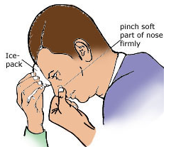
Management:
Self-help
You can stop virtually all nosebleeds yourself with a simple method.
- Sit down and bend your head forward. Hold a bowl under your nose.
- Firmly pinch the lower soft part of your nose between your thumb and finger for 5 minutes non-stop. Breathe through your mouth and do not let go for 5 minutes.
- It helps to have someone apply an icepack to the bridge of your nose, but the pressure you apply with your fingers is more important (it allows a blood clot to form).
- If the bleeding keeps coming back, contact physician who stop the bleedingby cauterizing with a special chemical,applying an ointment with an antiseptic or a chemical that constricts blood vessels

Sleep problems (319-324)
There is a problem when lack of sleep or too much sleep interferes with your activities during the day. The commonest cause is insomnia, which may be caused by anxiety or depression. There are other problems that can interfere with sleep, including problems of your bed mate. These problems include restless legs and snoring.
Patient education:
Concepts:
The amount of sleep we need for normal health varies with our age. Also, adults are different in the amount of sleep they need; for some, 4 hours a night is ample; for others, 10 hours is not enough. The average sleep for adult is 7 hours a day.
What is insomnia?
Insomnia is a lack of adequate sleep, which may be difficulty getting off to sleep, difficulty staying asleep, or waking early. It is a temporary problem in most instances.

Useful guidelines:
If you have difficulty going to sleep, the following guidelines might be useful:
- Establish a routine to follow before going to bed.
- Go to bed to sleep (not to read, talk, eat or watch television).
- Only lie down to go to sleep when you feel sleepy.
- Do not try to sleep immediately after a heavy meal, after difficult work that required a lot of concentration, after strenuous exercise or after an emotional upset or argument.
- Try to settle down before going to bed by the help of listening to the radio, or having a warm (not too hot) bath or shower or similar things.
- Often, having a warm milk drink as you retire to bed will help.
- Avoid drinks containing caffeine (such as tea, coffee and cocoa) as it make difficult to go to sleep.
- Avoidrepeated 'naps' during the day will make sleep at night difficult.
- In general, you will come to no harm if you do not sleep at all for one or two nights; you will catch up later.
- Avoid stress. Don't take your worries to bed.
- Avoid Drugs with CNS stimulant SE ex: nasal decongestant, caffeine should not be taken close to bedtimes.
- avoid Hunger, it can inhibit sleep
- Avoid smoking completely after noon.
- Bed room should be comfortable, no noise.

What about sleeping tablets?
Sometimes drugs can help you over a difficult period and may help you get into a pattern.
Some hypnotic drugs are suitable, but should be taken for a short time (say 2-3 nights) and taken in the lowest effective dose only under the supervision of your physician for addiction risk.

Snoring(325-330)

It is sonorous sound with breathing during sleep.
Patient education:
-Snoring is extremely common and only rarely indicates a disease like obstructive sleep apnoea (slowing or stopping of breathing for short periods while sleeping).
-It is three times more common in obese persons and increases as we get older.
-Snoring is generally a harmless problem. The social risks are a major problem as it can lead to a breakdown of relationships, to varying degrees.
What makes snoring worse?
- obesity
- old age
- sleeping on the back
- neck problems, especially a 'thick', inflexible neck
- various drugs, especially sedatives and sleeping pills
- problems in the upper airways
What is the treatment?
If an examination rules out a physical problem, the following simple measures can be tried:
- Obtain and keep to ideal weight.
- Avoid drugs (including sedatives and sleeping tablets), and smoking.
- Treat nasal congestion but avoid the overuse of nasal decongestants.
- For neck problems, keep the neck extended at night by wearing a soft collar.
- Consider a trial of an intranasal device such as the Breathing Wonder which is a hollow intranasal plastic insert. Your pharmacist can advise you about the range of such devices.
- Try to sleep on your side.
- Special anti-snoring pillows have not proved to be any better than regular pillows or raising the head of the bed.
- When all else fails, provide those affected in the household with ear plugs.
Varicose veins (331-336)
They are twisted and swollen veins caused by faulty valves in the system of veins in the leg. The failure of the valves to close properly causes blood returning to the heart to pool in the veins.
Patient education:
Concept:
Usually occurs in people who stand for long periods as “Barmen, hair dresser, surgeons, teachers”

How do they form?
Blood is collected from the leg in a network of superficial veins (just under the skin, on the surface of muscles). These veins are connected with deep veins in the muscles by perforating veins. When the muscles of the leg contract they pump the blood up these veins, which have one-way valves to prevent blood flowing back into the superficial veins.
When the valves do not close properly the blood tends to flow into the superficial veins, causing them to swell with the 'pooled' blood.

What are the symptoms?
The usual first sign is the appearance of prominent bluish swollen veins in your leg when you stand up. The usual site is either at the back of the calf or the inside of the leg from the ankle to the groin. At first they are not painful, but as the veins get larger they may become tender to touch and the skin above them or at the ankle may begin to itch.
With severe varicose veins the whole leg may ache and the skin, especially at the ankle, may become brownish. This discolored skin is called varicose eczema.
What are the risks?
Varicose veins are usually annoying and unsightly rather than disabling. Serious complications include the development of an ulcer in the skin (usually after an accident), Sometimes cut over a vein can cause severe bleeding. If this happens, put your leg up above your body and wrap a firm bandage around the bleeding vein.
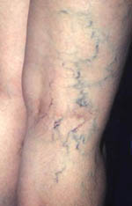
Recommendation:
- Don’t cross your leg on sitting.
- Avoid over weight & improve fitness & exercise.
- Avoid restrictive light cloth as restriction of blood flow will occur
- Avoid standing much as possible
- Whenever possible, sit with your legs up on a chair.
- Buy or get a prescription for support tights or stockings and put them on before you get out of bed every day.
- Do not scratch itchy skin over your varicose eczema.
- Drugs that support your vein circulation may be recommended.
- See your doctor if you develop eczema bleeding, or an ulcer.

Surgery
-The operation generally has good results, as the veins with the faulty valves are tied off or stripped away. It is possible to operate without leaving large scars.
-After surgery varicose veins tend to come back, usually in a different place, in about 10% of treated patients. So, previous recommendation should be followed.

Fever(337-342)
Fever is present when the temperature of the body (measured inside the mouth) rises above 37.2°C. The normal body temperature is up to 37°C. Fever is usually caused by a virus or bacteria. The temperature returns to normal when the infection settles.
Patient education:
Concepts:
-Most fevers are due to an infection in the body and are an important part of the body's defence against infection.
-It is normal for children, especially infants and toddlers, to have at least 5 or 6 episodes of fever a year.
-Fever is common in children, in whom the temperature may rise quickly to 38.5°C or higher. It does not mean the child has a serious illness.
-Do not worry if the child will not eat.
Recommendation:
- Do not overheat with too many clothes or blankets.
- Drink a lot of light fluids, especially water.
- Take aspirin orparacetamol tablets for relief or Giveparacetamol syrup every 4 hours until the temperature settles for children.
- Fan the patient if the fever is severe.
- Keep the child cool, but Cooling measures such as completely undressing the childsponging with lukewarm water and using fans are not necessary
Note:Seek medical attention for occurring with neck stiffness,convulsions,excessive drowsiness or repeated vomiting, earache or no improvement in 48 hours

Cramp (343-348)
Cramp is a painful spasm in the muscle, usually the calf muscles of the leg. The affected muscle feels hard and tense, and it is almost impossible to control it. Many people, especially the elderly, are often roused during sleep by sudden and severe cramps (night cramps)
Patient education:
Concepts:
-Cramp happens from time to time.
-Pregnant women are prone to cramps.
-There is usually no underlying cause other than unaccustomed exercise.
-It can also be caused by a prolonged period of sitting, standing or lying in an uncomfortable position.
What is the treatment?
The usual cramp lasts no longer than a minute or so and will usually clear up of its own.
It can be eased by firmly massaging the affected muscle and flexing the foot back towards you. It is easier if you can get someone to do this for you.
-the use of muscle relaxant and analgesic may be recommended
How can night-time cramps be prevented?
Medication: mainly muscle relaxant.
Pillows at the foot of the bed: placing a doubled up pillow under the sheet at the foot of the bed so that the feet are kept bent back towards you during sleep.
Exercises:Certain muscle stretching and relaxation exercises help prevent cramps.
Exercise 1: Stand barefoot about 1 metre from a wall, lean forward with the back straight and your outstretched hands against the wall (as in the diagram). Hold this position for 20 seconds and repeat about 5 times. Do this exercise 2-3 times a day for a week and then each night before retiring.
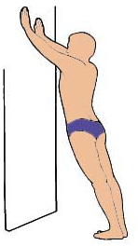
2-Muscle strains
Patient education:
Concept:
-You can 'pull' (strain or tear) a muscle if you do not warm up properly before exercising.
-Reusable soft-fabric cold compresses that can be stored in a freezer (at least 2 hours) and cold packs are available and are ideal for the athlete to have always available.
-Do not return to sport until the pain and swelling have gone, the muscle is strong and you can move the limb freely without discomfort.
-never apply ice directly to the skin.
-If the injury is severe, or canot move your finger contact physician immediately (risk of bone fracture)

Management of a pulled muscle is based on 'RICE':
Rest | No exercise, no stretching; rest the injured soft tissue of the muscle.
Ice | Apply an icepack for 20-30 minutes every 2 hours while awake during the first 48 hours.
Compression | Keep the muscle firmly bandaged for at least 48 hours.
Elevation | Rest the leg on a chair until the swelling goes.
-After resting the muscle for a few days, stretching can begin. Warm the area first with a hot-water bottle (thermotherapy). Then stretch your leg or arm about 5 times to contract the muscle gently. Do this twice each day for 14 days.

Sprained ankle(349-354)

A sprain occurs when there is damage to the ligaments or tendons that bind the bones of the ankle joint. The fibers of the ligament that has been overstretched tear and then bleed. The tear is usually minor, involving a small number of fibers, but sometimes the ligament can be completely torn.
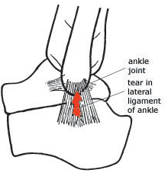
Patient education:
Concept:
-Sprained ankles are very common. In an average year, at least 1 person in 50have
-falling of stairs may be a cause for sprained ankles.
-Avoid use of counterirritant with thermotherapy as counter irritants increase superfacial blood flow increasing risk of local heat.
-Not advise counter irritant with L.A. or analgesic as they will numb skin abolishing counter irritant effects.
What is the cause?
The cause is a sudden twist of the foot inwards so that the ligaments on the outside of the ankle are overstretched.
What are the symptoms?
The symptoms depend on the extent of the damage. Pain, swelling, bruising and tenderness of the injured area usually occur and vary from mild to severe. With a complete tear the ankle joint will go out of shape and feel unstable.
What is the treatment?
For a mild sprain, self-help measures are usually sufficient. However, a severe sprain requires an X-ray, since there may be a fracture or a complete tear.

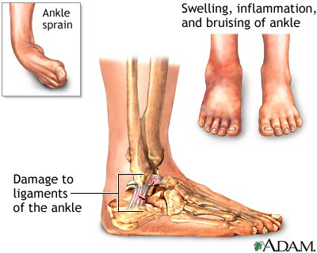

Management:
Rest | Rest as much as possible. If the sprain is severe, use crutches to take the weight off the ankle.
Ice | Apply icepacks and/or soak the ankle in cold water to reduce swelling and pain. Use the icepack for about 20-30 minutes every 3 hours when awake for the first 48 hours. (Icepacks can be placed over a bandage.)
Compression | Compress and support the ankle with a firm (not tight) elastic bandage.
Elevation | Elevate the leg or chair until the swelling goes.
-After resting the muscle for a few days, stretching can begin. Warm the area first with a hot-water bottle (thermotherapy). Then stretch your leg or arm about 5 times to contract the muscle gently. Do this twice each day for 14 days.

Pain-killers:Paracetamol with or without codeine is usually sufficient.
Exercise program
Exercises started early will help prevent permanent stiffness. Exercise every hour up to the point of discomfort. Do each exercise at least 10 times.
- Firmly flap your foot up and down at the ankle joint.
- Rotate your foot inwards and outwards, keeping the foot at right angles to the leg.
- Combine these exercises so that your foot moves slowly in a circle (clockwise, then anticlockwise).
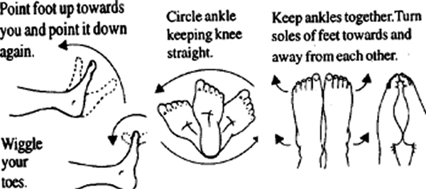
Walking:
Walking with your ankle supported in comfortable walking shoes is recommended for short distances. Walk as normally as possible, but avoid standing for long periods. Walking without shoes in sand is an excellent way of strengthening your ankle quickly (after the first 2-3 days).

Tennis elbow (355-360)

Lateral epicondylitis ('tennis elbow' or 'backhand tennis elbow') is inflammation of an important forearm muscle tendon at the point of attachment to the outer side of the elbow bone. Tennis players are not the only sufferers. It is common in golfers, carpenters, bricklayers, violinists and housewives, especially those between 35 and 55 years of age.
Patient education:
Concepts:
- Start the game quietly, taking time to warm up to it.
- it is advisable to stop the sport if possible
-Sometimes it can take 1-2 years to heal.
-the use a non-stretch band or brace around the arm is recommended
What causes it?
Tennis elbow is the result of repeated bending and twisting movements of the arm, such as when playing golf and tennis, using a screwdriver, wringing wet clothes, carrying buckets or picking up bricks. The force of the ball hitting the racquet is greater than the strength of the muscle; the muscles of the forearm thus become overstrained. The strains, initially painless, cause small tears in the tendon. As they start to heal, more tears occur and painful inflamed scar tissue forms.
What are the symptoms?
The outer bony projection of the elbow (the lateral epicondyle) is painful. For some people the pain is constant and can interfere with sleep.
The forearm aches with grasping and lifting movements such as pouring tea, turning stiff handles, ironing clothes and typing.
What is the treatment?
Tennis elbow is almost always curable. The two bases of treatment are:
- rest (avoiding the cause, e.g. stop playing tennis)
- exercise (to strengthen the forearm muscles, which bend the wrist)
- a cortisone injection by physician to speed recovery.
Exercises
Use a dumbbell. Start with 0.5 kg (1 lb) and build up gradually to 5 kg.
- Sit in a chair beside a table.
- Rest your arm on the table so that the wrist is over the edge.
- With your palm facing downwards, grasp the weight.
- Slowly raise and lower the weight 12 times. Rest for 1 minute.
- Repeat twice.
Do the exercise every day until you can work or use your forearm without pain.
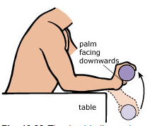
Armbands
Some tennis players use a non-stretch band or brace around the arm, about 7.5 cm (3 inches) below the elbow.

